What is an acquittal?
An acquittal is a formal condition of funding whereby funding recipients accurately report on the funded activities and the expenditure of the funding. Acquittals are used to:
- fulfil obligations of accountability
- assist development of current and future programs
- evaluate achievements of funded activities
- monitor the effectiveness of the funding program

Do I Need to submit an acquittal?
Successful applicants are required to meet the reporting requirements specified in Clause 3 of the executed Funding Agreement. You must keep accurate records (including all receipts and tax invoices) and provide access to and copies of the records to Parks Victoria in relation to the activity and for everything you purchase with the funding.

Record retention
Make sure you retain all records in relation to the project and activities for a period of seven (7) years after the Funding Agreement and project has closed.

When do I complete the acquittal?
All successful applicants will be required to complete and submit an acquittal upon completion of the project. The acquittal will be available to complete on ParkConnect once your project plan has been approved. All acquittals must be submitted to Parks Victoria within 12 months from the deposit of funding from Parks Victoria.

Supporting Documentation
Make sure you can provide ALL supporting documentation that is required by the funding guidelines. Your acquittal may not be approved if required documentation is not submitted. Types of supporting documentation include:
- Invoices and receipts
- Proof of works
- Photos
- Copies of project publicity
- Feedback
- Reports

Notification of project closure
Parks Victoria will review your acquittal and respond within 4 weeks.

Further Information
Fact Sheet VIF Successful Applications
Fact Sheet VIF Publicising Successful Projects
Parks Victoria Volunteering Manual
www.parkconnect.vic.gov.au

Legal accountability
Parks Victoria is legally responsible to properly account for public money. This responsibility includes accounting for any funds provided to groups through Parks Victoria, under any funding program. By accepting funds from Parks Victoria, the group also becomes legally accountable to ensure that the public money is properly spent.

Contact us
If you have any queries, or require more information, please contact Parks Victoria via: email: VolunteeringFund@parks.vic.gov.au or phone: 1300 375 323

Access the Volunteering Innovation Fund
To access the Volunteering Innovation Fund click on the below icons on the ParkConnect home page:
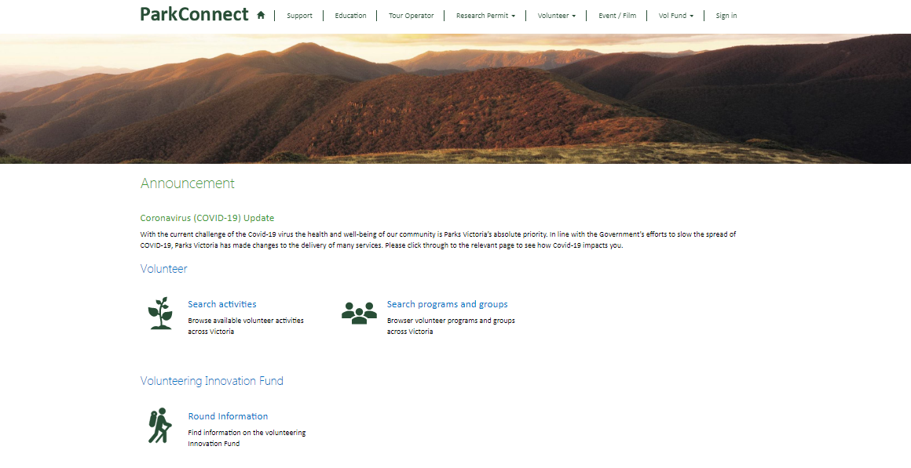
You will be taken to the Volunteering Innovation Fund (VIF) landing page. You can access the VIF dashboard, your applications and project plans through the blue outlined button, or through the top navigation bar.
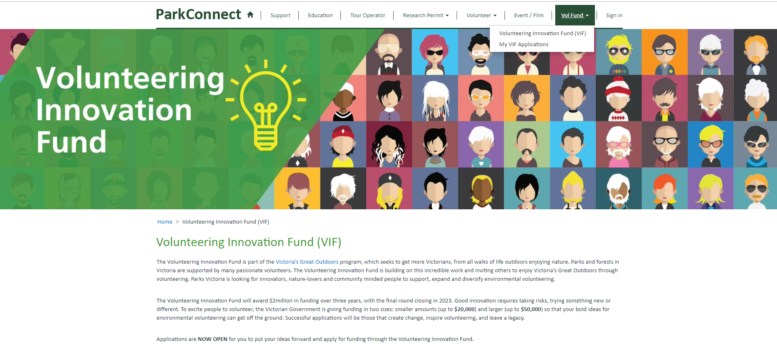

You can access the Funding Guidelines and Fact Sheets on the landing page through the following links. You can also find them on www.parkconnect.vic.gov.au/vif

The VIF dashboard allows you to commence and manage your applications, including project plans and acquittals. You can access your acquittal on your VIF dashboard. If you save a draft acquittal, you can access it to review, edit, proof read or submit by clicking on the Application ID or the drop down arrow.
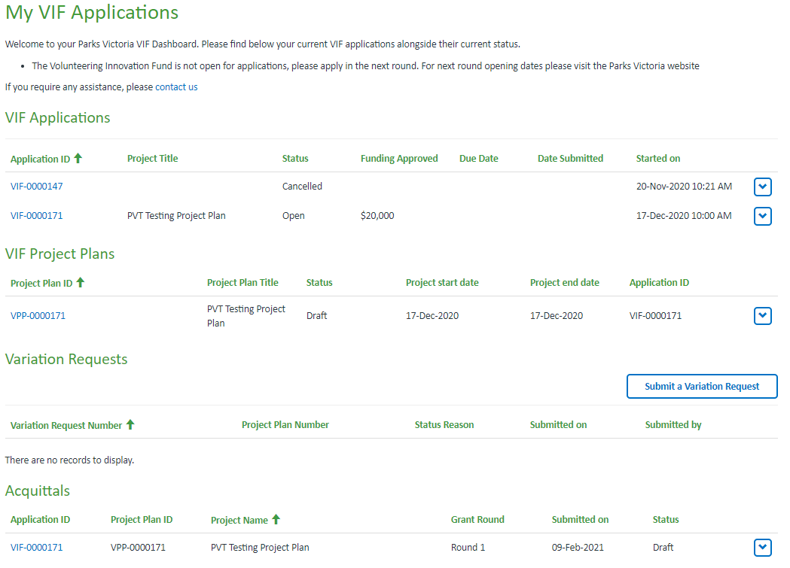

Once you have submitted your acquittal you are unable to edit. The acquittal will become ‘view only’.

Start the acquittal
To start the acquittal, click on the drop down arrow and “Complete Acquittal” on your VIF dashboard. This will take you to the first page of the acquittal.

Recipient Overview
The information in the Recipient Overview section will be copied across from your application. Please read through to make sure it is still accurate. You will not be able to edit the Grant and Recipient Details information.
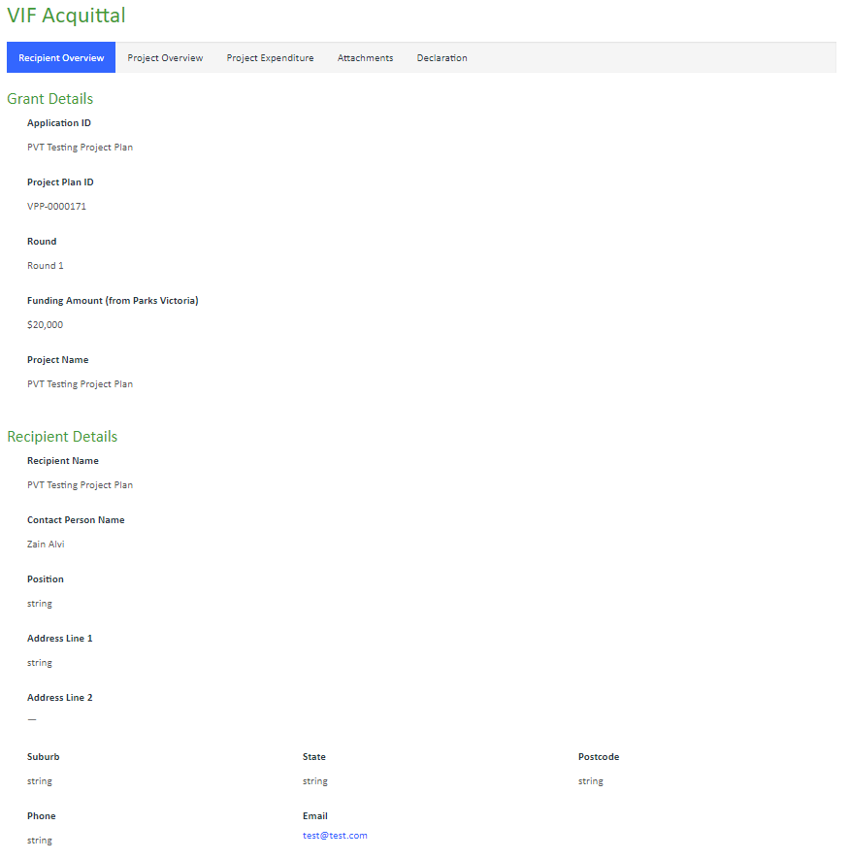
Read through the Recipient Overview area and check if still current. You can update if required.
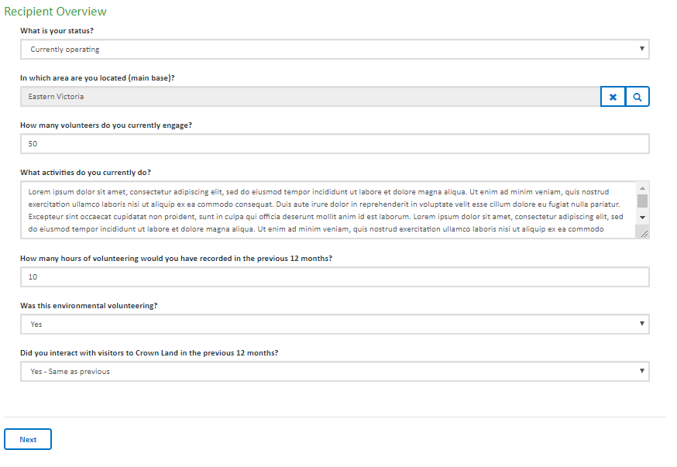
Once you have filled out all mandatory fields, you can click Next to save your acquittal and progress to the next page.

The acquittal will not save until all mandatory fields are completed (and correct). If any of the mandatory fields are not completed correctly, the errors will list at the top of the page in red. You must correct these errors to save, exit to the VIF dashboard or proceed to the next page. Your acquittal will not save if there are incomplete fields or errors.

Project Overview
The information in the Project Overview section will capture your project achievements and any lessons learnt.
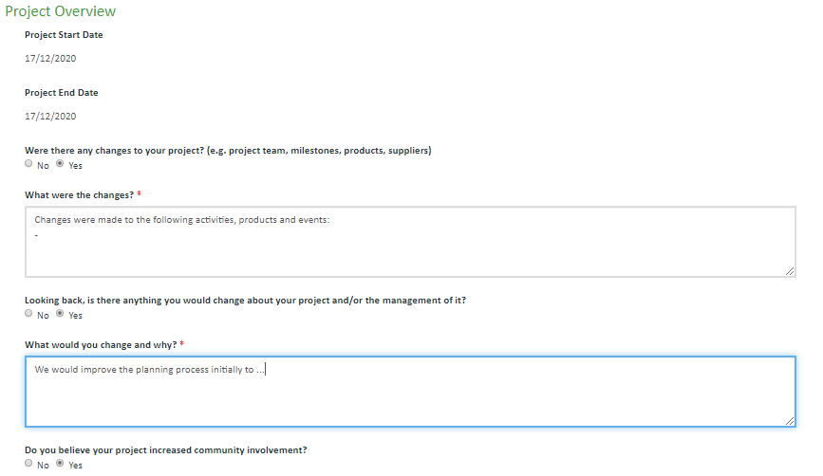
The Project Achievements will be copied across from your project plan. Review these objectives and only select ‘Yes’ to those achieved.
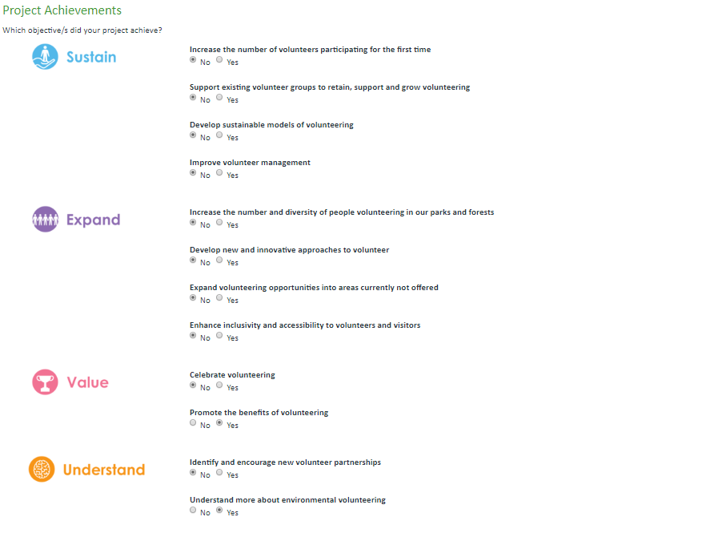
Review the measurements you nominated to determine the success of your project. Add the real data in the ‘Actual’ field to measure whether your KPI’s were met. To add the real data, click on the drop down arrow of the applicable measure. Select ‘Edit’.

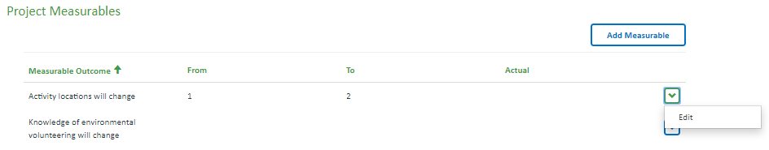

A pop-up-box will open. Use the text boxes to type your real data in the Actual field and then click ‘submit’.

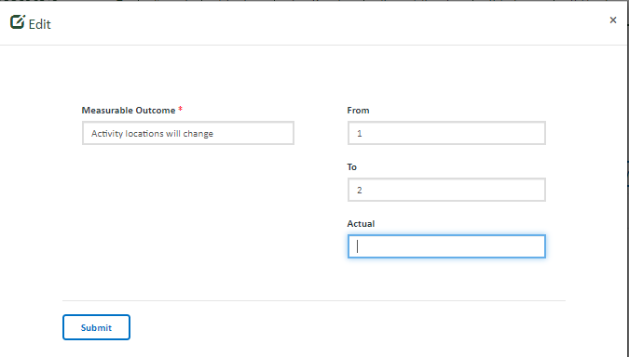

Upon clicking submit, you will return to the acquittal. The data will now be shown in the table.
You can add more measurables by using the above instructions.

If there were any unexpected outcomes, select yes using the radio buttons and describe them in the following text field

Use the following fields to explain if the project met your expectations and any lessons you would like to share.

Once you have filled out all mandatory fields, you can click Save & Exit or Next to save your acquittal.
Save & Exit will save the acquittal and exit to the VIF Dashboard. The acquittal will be saved as a draft and available in your VIF dashboard to edit, complete and submit. The acquittal will only be editable if in draft status (un-submitted). Once the acquittal is submitted, the form will become view only.
Previous will return to the previous page.
Next will save the application and progress to the next page.
The acquittal will not save until all mandatory fields are completed (and correct). If any of the mandatory fields are not completed correctly, the errors will list at the top of the page in red. You must correct these errors to save, exit to the VIF dashboard or proceed to the Next page. Your acquittal will not save if there are incomplete fields or errors.

Project Expenditure
The information in the Budget section will be copied across from your application. As these are based on your planned financial transactions, please read through to make sure they are now accurate.

The Actual Budget records the financial contributions that occurred throughout the project. You can edit the funding amounts in the Actual Budget by typing in the text fields. You will not be able to edit the Funding Awarded amount.

The Actual Budget breakdown records the financial transactions that occurred throughout the project. Read through the Budget Breakdown. If you would like to edit the budget item, click on the drop down arrow of the applicable item and select ‘Edit’.

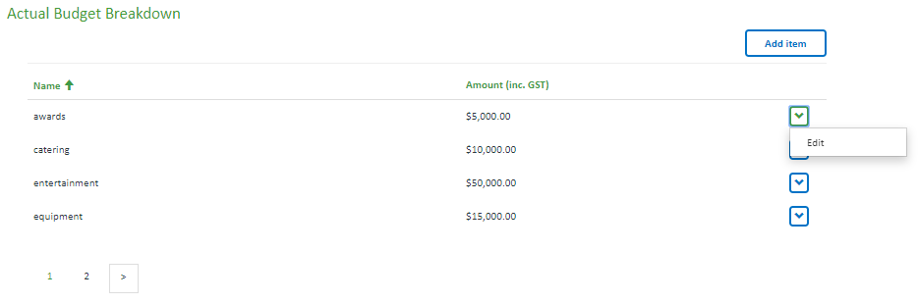

A pop-up-box will open. Use the text boxes to edit your item and then click ‘submit’.
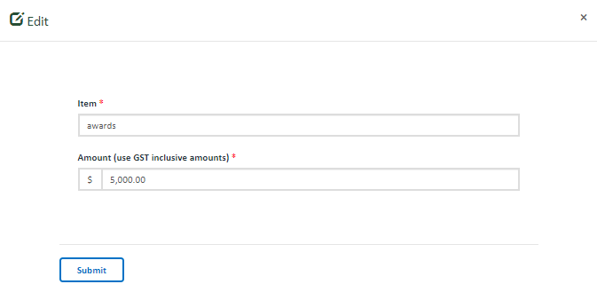
Upon clicking submit, you will return to the acquittal. The edited item will now show in the table.
To remove a budget item, click on the drop down arrow of the applicable item and select ‘Remove’. Upon clicking remove, you will return to the project plan. The item will not show in the table.

To add new items, click on the ‘Add item’ button outlined in blue.
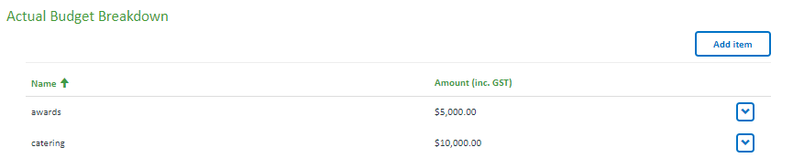

A pop-up-box will open. Use the text boxes to add your item and then click ‘submit’.
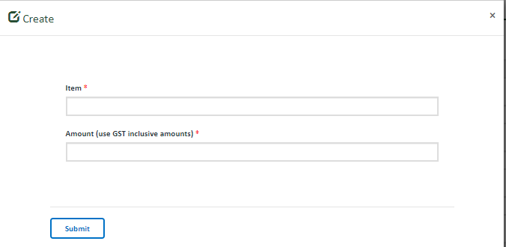

Upon clicking submit, you will return to the acquittal. The new item will now show in the table.
You can add more items by using the above instructions.

Once you have filled out all mandatory fields, you can click Save & Exit, Previous or Next to save your acquittal.
Save & Exit Button will save the acquittal and exit to the VIF Dashboard. The acquittal will be saved as a draft and available in your VIF dashboard to edit, complete and submit. The acquittal will only be editable if in draft status (un-submitted). Once the acquittal is submitted, the form will become view only.
Previous Button will save the acquittal and return to the previous page.
Next Button will save the acquittal and progress to the next page.
The acquittal will not save until all mandatory fields are completed (and correct). If any of the mandatory fields are not completed correctly, the errors will list at the top of the page in red. You must correct these errors to save, exit to the VIF dashboard or proceed to the Next page. Your project plan will not save if there are incomplete fields or errors.

Attachments
The Attachments page provides you the opportunity to attach all required documentation and the ability to further demonstrate the community support received and success of your project. Upload the documents in the relevant category.

You must upload copies of:
- all invoices/proof of payments/receipts
- publicity/marketing
You can also upload copies of photos, surveys, reports or other supporting documents in the other categories.
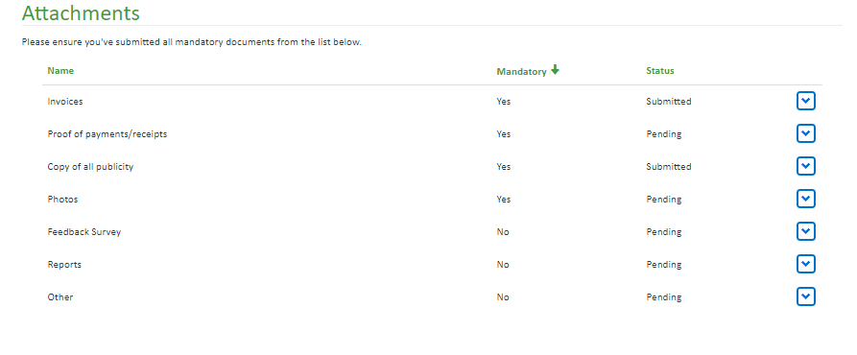
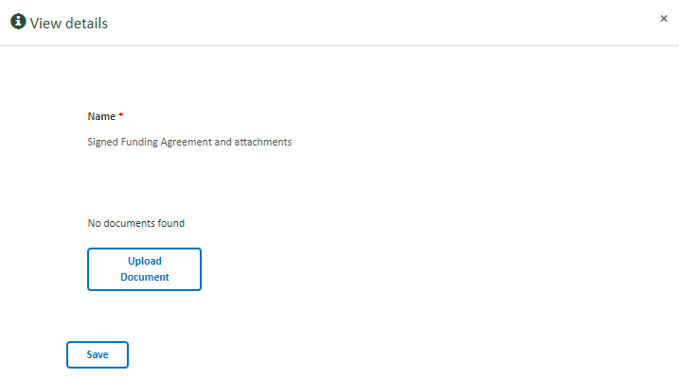
To upload documents, click on the drop down arrow of the applicable item and select ‘Upload/Edit’.
A pop-up-box will open.
Click on the Upload Document button.

A further pop-up box will open.

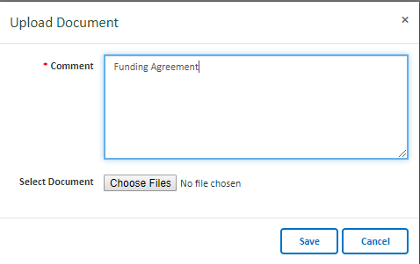

Enter the name of the document. The document will not upload
unless this field is completed. This field will assist with identification of the
document.

Click on the Choose Files button.

A pop-up box will open. Select the document and click open. The document will now show here.

Click on the Save button.

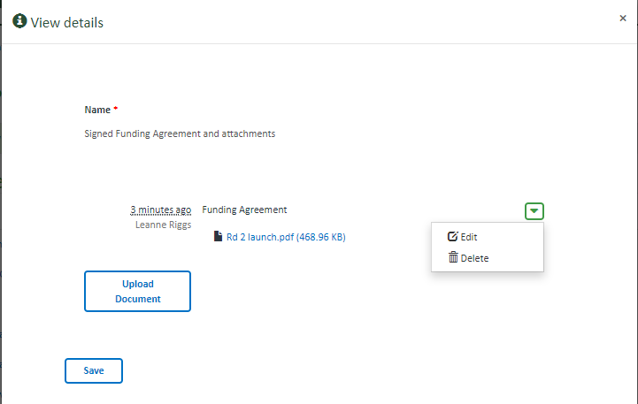
You will return to the View Details pop-up box.

The uploaded document should now show. You can edit or delete
the document by clicking on the drop down arrow.

You can upload more documents to this category by clicking on the
Upload Document button and repeating the above instructions.

Once all documents within this category are uploaded, click on the
Save button.

Upon clicking Save you will return to the acquittal. The Status in the table will now show as submitted. You can edit the uploaded documents by clicking on the drop down arrow.

Upload more documents to the other categories by repeating the above instructions.

Once you have filled out all mandatory fields, you can click Save & Exit, Previous or Next to save your acquittal.
Save & Exit Button will save the acquittal and exit to the VIF Dashboard. The acquittal will be saved as a draft and available in your VIF dashboard to edit, complete and submit. The acquittal will only be editable if in draft status (un-submitted). Once the acquittal is submitted, the form will become view only.
Previous Button will save the acquittal and return to the previous page.
Next Button will save the acquittal and progress to the next page.
The acquittal will not save until all mandatory fields are completed (and correct). If any of the mandatory fields are not completed correctly, the errors will list at the top of the page in red. You must correct these errors to save, exit to the VIF dashboard or proceed to the Next page. Your project plan will not save if there are incomplete fields or errors.

Declaration
The Declaration page confirms your responsibilities when submitting the acquittal. You must agree to the declarations to submit the acquittal.

If you agree with the declarations, select yes.

The documents checkbox will automatically select dependent on the documents you upload. You will not be able to submit the acquittal unless you have completed all mandatory fields and uploaded the mandatory attachments.

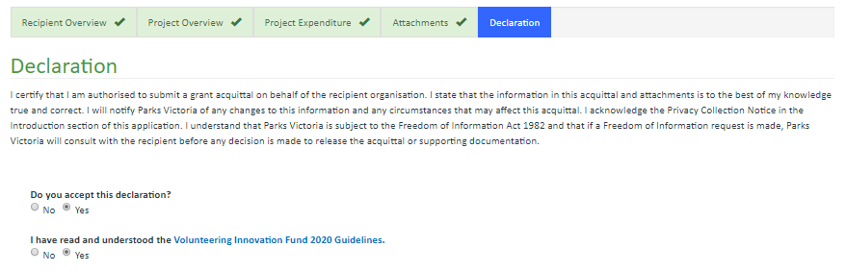

Once you have reviewed the declaration, you can click Save & Exit, Previous or Submit.

Save & Exit will save the acquittal and exit to the VIF Dashboard. The acquittal will be saved as a draft and available in your VIF dashboard to edit, complete and submit. The acquittal will only be editable if in draft status (un-submitted). Once the acquittal is submitted, the form will become view only.

Previous will save the application and return to the previous page.

Submit will save the acquittal and Submit to us for review. Once submitted you will no longer be able to edit your acquittal. Once submitted, the nominated Contact person will receive an email confirming the acquittal has been submitted. You can return to the Dashboard to view the acquittal at any stage.

