When do I complete the project plan?
All successful applicants will be required to complete and submit a project plan. The project plan will be available to complete on ParkConnect upon notification of application success. All project plans must be submitted to Parks Victoria within 60 days.

Agreement

Successful applicants will be required to sign an Agreement with Parks Victoria outlining the requirements of both the recipient (you) and the Fund provider (Parks Victoria). The project plan will be included as an addendum and form part of the Agreement.

Funding
When submitting your Project Plan through ParkConnect, attach the signed Funding Agreement and invoice.

Parks Victoria will approve the project plan, execute the Funding Agreement and process the invoice. For more information, see Fact Sheet: VIF Successful Applications.

Can I complete my own project plan?
Successful applicants must complete the project plan provided on ParkConnect. Each successful application will have its own unique project plan to complete. Applicants have the ability to attach their own gantt charts, see Page 19.

Further Information
Fact Sheet VIF Successful Applications
Fact Sheet VIF Publicising Successful Projects
www.parkconnect.vic.gov.au

Legal accountability
Parks Victoria is legally responsible to properly account for public money. This responsibility includes accounting for any funds provided to groups through Parks Victoria, under any funding program. By accepting funds from Parks Victoria, the group also becomes legally accountable to ensure that the public money is properly spent.

Contact us
If you have any queries, or require more information, please contact Parks Victoria via: email: VolunteeringFund@parks.vic.gov.au or phone: 1300 375 323

Access the Volunteering Innovation Fund
To access the Volunteering Innovation Fund click on the below icons on the ParkConnect home page:
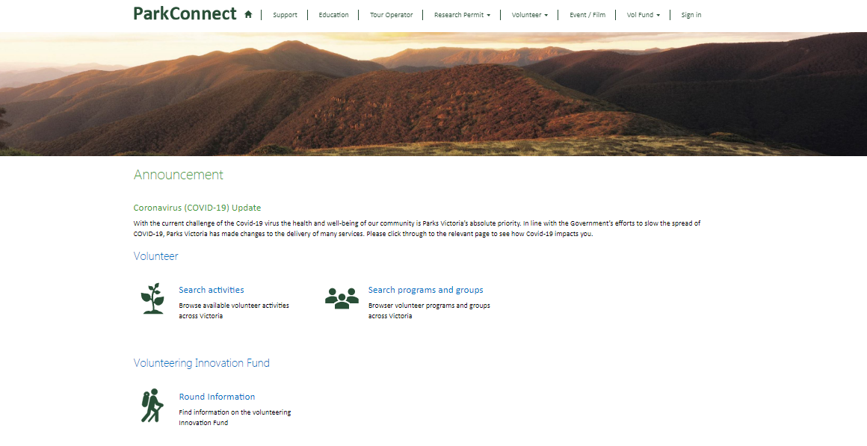You will be taken to the Volunteering Innovation Fund (VIF) landing page. You can access the VIF dashboard, your applications and project plans through the blue outlined button, or through the top navigation bar.
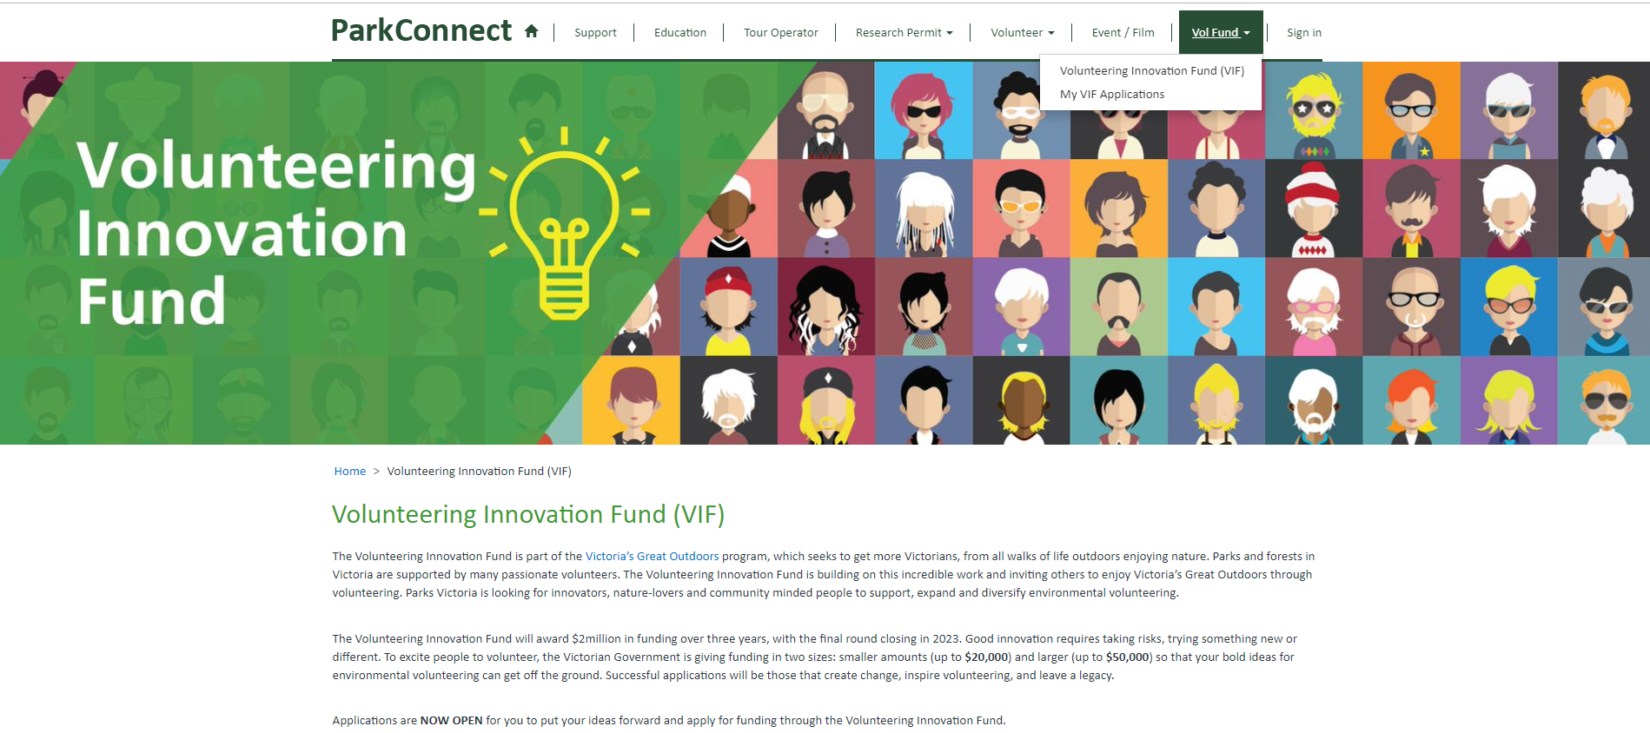

You can access the Funding Guidelines and Fact Sheets on the landing page through the following links. You can also find them on www.parkconnect.vic.gov.au/vif

The VIF dashboard allows you to commence and manage your applications, including project plans and acquittals. You can access your project plan by clicking the blue outlined button on the landing page or on your VIF dashboard.

Your draft and submitted project plans will be accessible through your VIF dashboard. If you save a draft project plan, you can access it to review, edit, proof read or submit by clicking on the Application ID or the drop down arrow. Once you have submitted your project plan you are unable to edit. The project plan will become ‘view only’.

Start the project plan
To start the project plan, click on the drop down arrow and “Edit project Plan” on your VIF dashboard. This will take you to the first page of the application.

Project Overview
The information in the Project Overview section will be copied across from your application. Please read through to make sure it is still accurate. You will not be able to edit the Grant Details information.
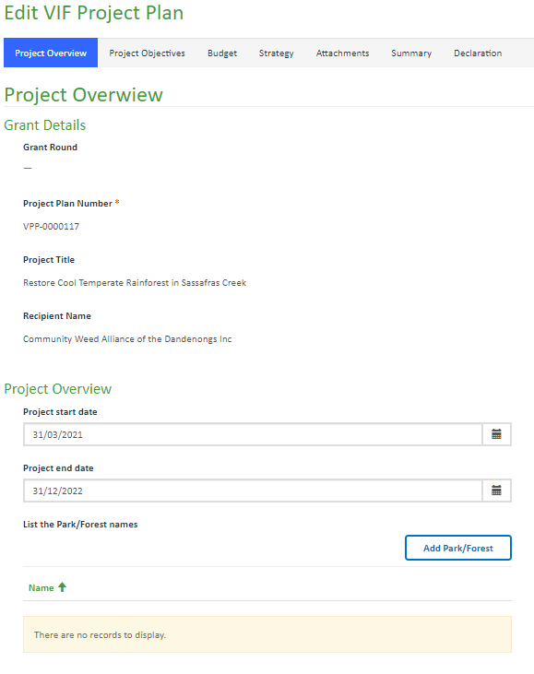
You will need to list the specific Parks and Forests our project will be conducted in. To add the Parks/Forest click on the blue outlined button.
A pop-up-box will open. Use the Search function to select the applicable Parks/Forests from the list and then click Add.

Upon clicking Add (or Cancel) you will return to the project plan. The selected Parks/Forests will now show in the table.
You can remove areas by clicking on the drop down arrow and selecting ‘Remove’.
You can add more areas by using the above instructions.

Continue down the page and review the Recipient Overview.

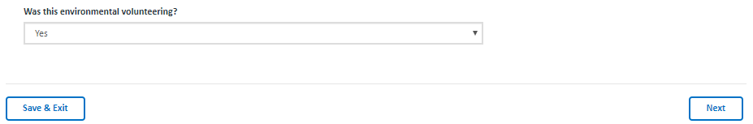

Once you have filled out all mandatory fields, you can click Save & Exit or Next to save your project plan.
Save & Exit will save the project plan and exit to the VIF Dashboard. The project plan will be saved as a draft and available in your VIF dashboard to edit, complete and submit. The project plan will only be editable if in draft status (un-submitted). Once the project plan is submitted, the form will become view only.

Next will save the application and progress to the next page.

The project plan will not save until all mandatory fields are completed (and correct). If any of the mandatory fields are not completed correctly, the errors will list at the top of the page in red. You must correct these errors to save, exit to the VIF dashboard or proceed to the next page. Your project plan will not save if there are incomplete fields or errors.

Project Objectives
The information in the Project Objectives section will capture your project goals.
The Project Achievements will be copied across from your application form. Review these objectives and only select ‘Yes’ to those you will use to create project measurables (KPI’s) for.
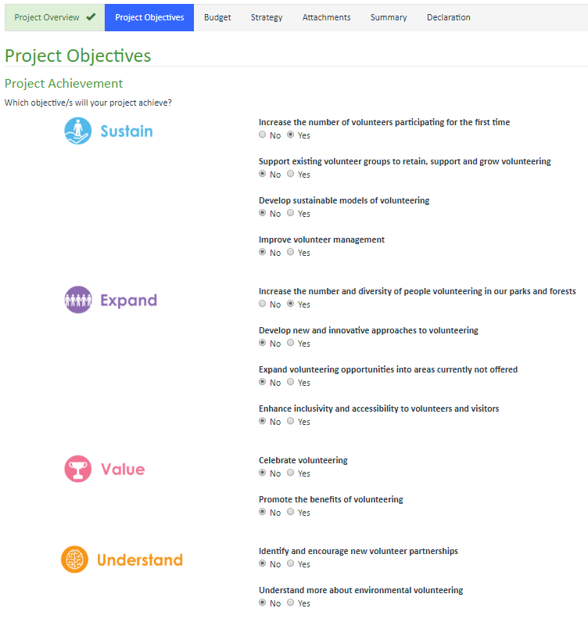
Add the measurements you will use to determine the success of your project. You must have at least one measurable. You can use the provided examples and/or create your own. Add the current data in the ‘from’ field and your KPI in the ‘to’ field. You can use any measurable data type, including (but not limited to) percentage, numbers, locations.
For example:

Read through the list and if applicable, click on the drop down arrow of the applicable measure. Select ‘Edit Measurable’.

A pop-up-box will open. Use the text boxes to type your measures and then click ‘submit’.

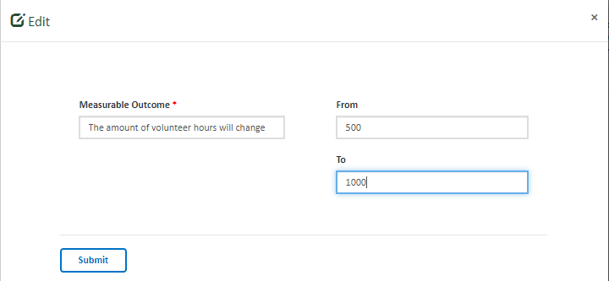

Upon clicking submit, you will return to the project plan. The measurable will now be shown in the table.
You can remove measurables by clicking on the drop down arrow and deleting the data from the text fields.
You can add more measurables by using the above instructions.
To add your own measurable, click on the ‘Add Measurable’ button outlined in blue.
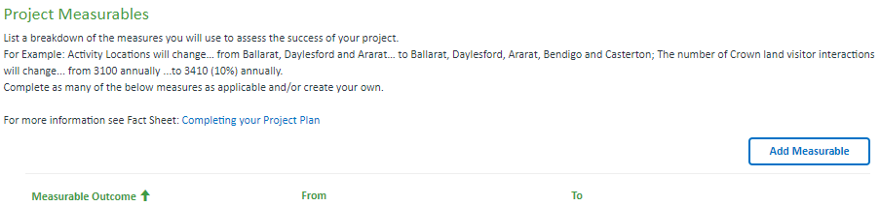

A pop-up-box will open. Use the text boxes to type your measures and then click ‘submit’.

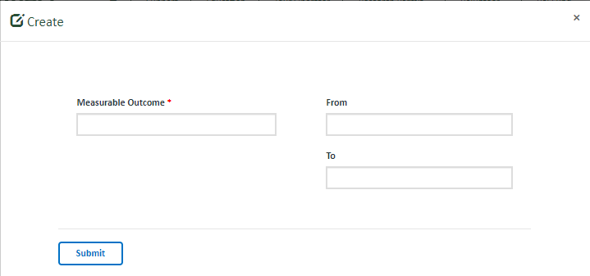

Upon clicking submit, you will return to the project plan. The measurable will now be shown in the table.
You can remove and edit measurables by clicking on the drop down arrow and deleting the data from the text fields.
You can add more measurables by using the above instructions.
Once you have filled out all mandatory fields, you can click Save & Exit, Previous or Next to save your project plan.
Save & Exit will save the project plan and exit to the VIF Dashboard. The project plan will be saved as a draft and available in your VIF dashboard to edit, complete and submit. The project plan will only be editable if in draft status (un-submitted). Once the project plan is submitted, the form will become view only. Previous will save the application and return to the previous page.
Next will save the application and progress to the next page.
The project plan will not save until all mandatory fields are completed (and correct). If any of the mandatory fields are not completed correctly, the errors will list at the top of the page in red. You must correct these errors to save, exit to the VIF dashboard or proceed to the Next page. Your project plan will not save if there are incomplete fields or errors.

Budget
The information in the Budget section will be copied across from your application. Please read through to make sure it is still accurate. You will not be able to edit the Funding Awarded amount.

You can edit the funding amounts in the Project Budget by typing in the text fields.
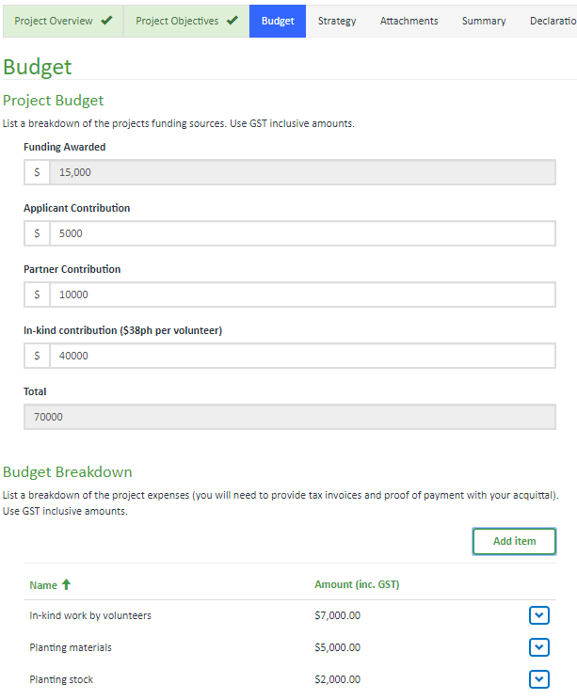
Read through the Budget Breakdown. If you would like to edit the budget item, click on the drop down arrow of the applicable item and select ‘Edit’.

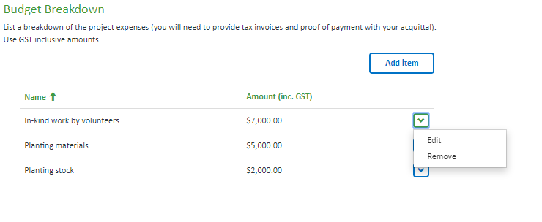
A pop-up-box will open. Use the text boxes to edit your item and then click ‘submit’.
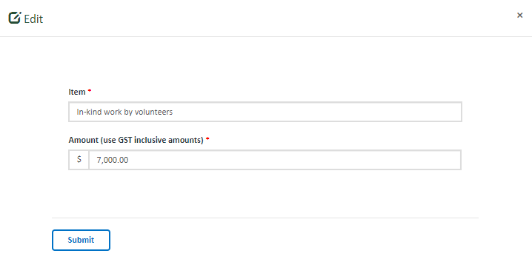
Upon clicking submit, you will return to the project plan. The edited item will now show in the table.
To remove a budget item, click on the drop down arrow of the applicable item and select ‘Remove’. Upon clicking remove, you will return to the project plan. The item will not show in the table.
To add new items, click on the ‘Add item’ button outlined in blue.
A pop-up-box will open. Use the text boxes to add your item and then click ‘submit’.
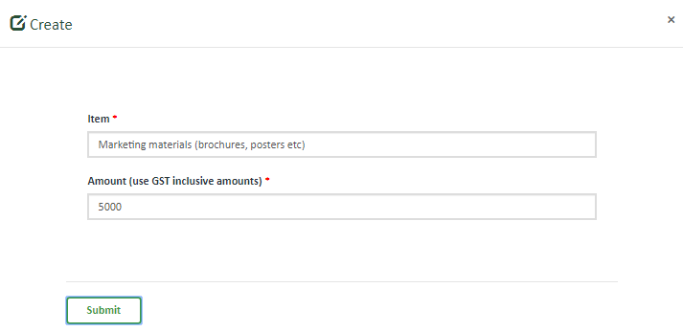

Upon clicking submit, you will return to the project plan. The new item will now show in the table.
You can add more items by using the above instructions.

Once you have filled out all mandatory fields, you can click Save & Exit, Previous or Next to save your project plan.
Save & Exit Button will save the project plan and exit to the VIF Dashboard. The project plan will be saved as a draft and available in your VIF dashboard to edit, complete and submit. The project plan will only be editable if in draft status (un-submitted). Once the project plan is submitted, the form will become view only.
Previous Button will save the application and return to the previous page.
Next Button will save the application and progress to the next page.
The project plan will not save until all mandatory fields are completed (and correct). If any of the mandatory fields are not completed correctly, the errors will list at the top of the page in red. You must correct these errors to save, exit to the VIF dashboard or proceed to the Next page. Your project plan will not save if there are incomplete fields or errors.

Strategy
The information in the Strategy section will be used to capture how you will complete your project. Use this section throughout your project to make sure you stay on track.
You can complete this section or attach your own project plan/gantt chart in the attachments section. If you do not complete this section, you must attach suitable document/s which include all required information (project team, project milestones and tasks) as a minimum.

List all those who will form part of the team to see the project through to completion. The same person can be responsible for more than one role. You can use the provided examples and/or create your own. To add the person responsible click on the drop down arrow of the applicable measure. Select ‘Edit’.
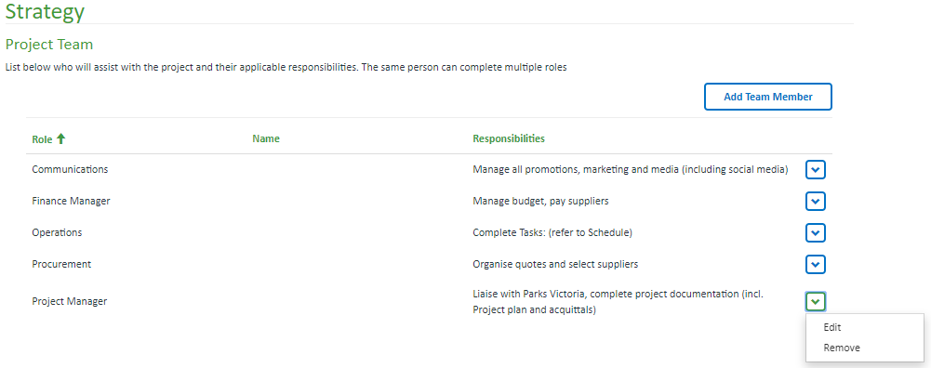
A pop-up-box will open. Use the text boxes to add the name of the person responsible. You can also add their contact details (these details will be for your own benefit and will not be used by Parks Victoria). Once complete, click ‘Submit’.

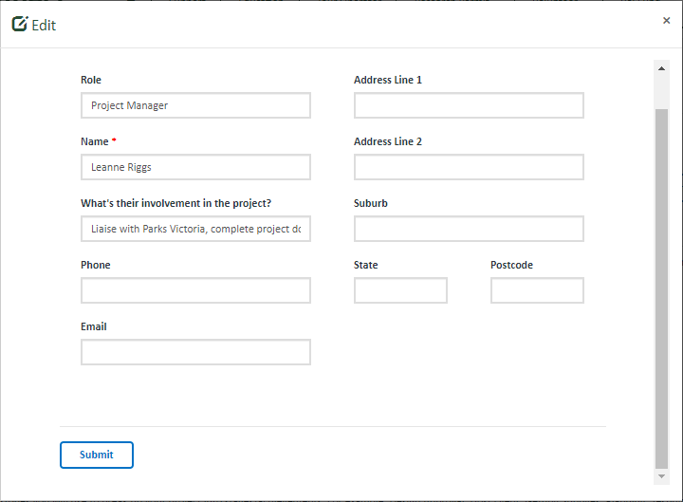
Upon clicking submit, you will return to the project plan. The amended details will now show in the table.
You can edit the other roles and add names of those responsible by using the above instructions.
To add more roles, click on the ‘Add Team Member’ button outlined in blue.
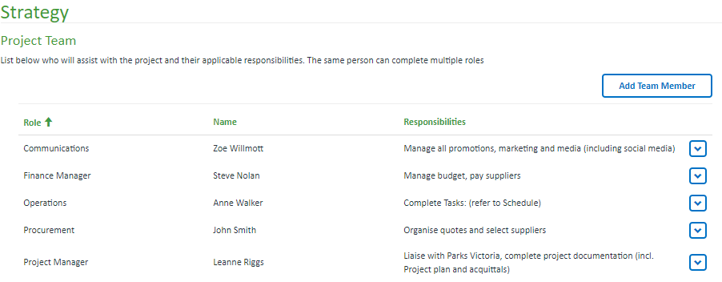
A pop-up-box will open. Use the text boxes to add the role, name and responsibilities and then click ‘Submit’.
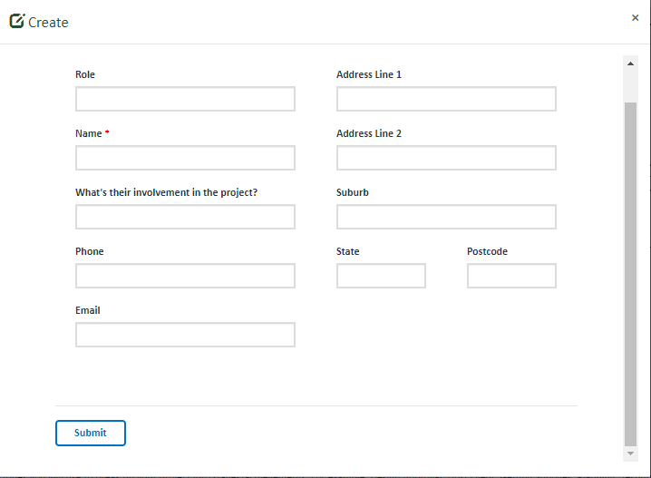
Upon clicking submit, you will return to the project plan. The added details will now show in the table. You can add more items by using the above instructions.

The Milestones are used to breakdown your project into stages. An example of Milestones (for an App project) include:
- Plan project
- App design
- App testing
- App complete
- Promotion
- App usage

To add a milestone, click on “Add Milestone” outlined in blue.
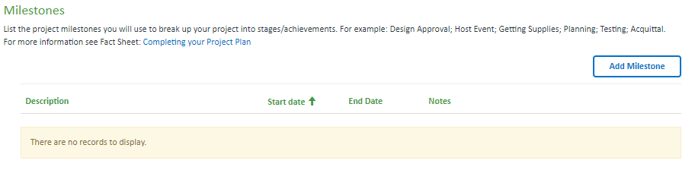
A pop-up-box will open. Use the text boxes to add the milestone, dates and any applicable notes, then click ‘Submit’.
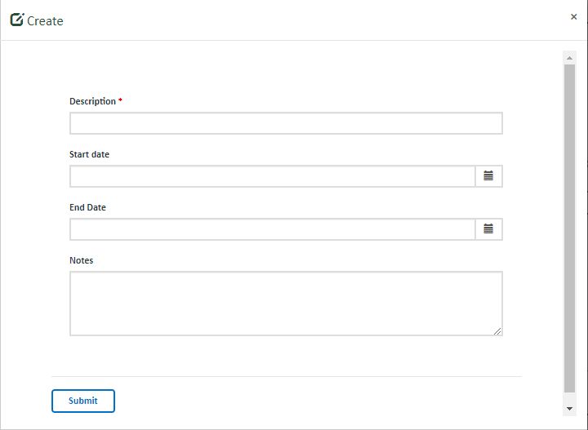
Upon clicking submit, you will return to the project plan. The Milestone will now show in the table. You can add more items by using the above instructions.
You can edit the milestones by clicking on the drop down arrow and selecting ‘Edit’.
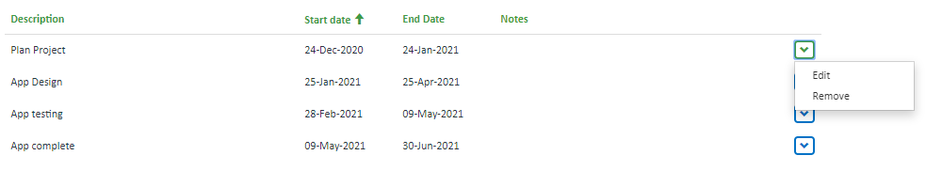

A pop-up-box will open. Use the text boxes to edit the milestone, dates and any applicable notes, then click ‘Submit’.
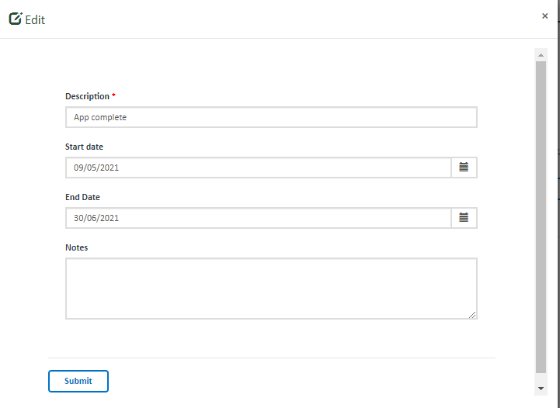
Upon clicking submit, you will return to the project plan. The Milestone will now show in the table. You can edit more items by using the above instructions.

You can remove the milestones by clicking on the drop down arrow and selecting ‘Remove’.
Upon clicking Remove, you will return to the project plan. The Milestone will be removed. You can remove more items by using the above instructions.
The Schedule is used to breakdown your project and milestones into tasks. Each Milestone will need tasks undertaken to complete the stage. An example of a Schedule includes:

- Plan project
  - Complete project plan
  - Complete communications plan
  - Co-ordinate suppliers
- App design
  - Brief to developer
  - Deposit $ to developer
  - Developer designs app
- App testing
  - Initial testing of stage 1
  - Initial testing of stage 2
  - Testing of Stage 1 & 2
  - Fixes/enhancements
- App complete
  - App development complete
  - App deployed for use
- Promotion
  - Pre-release marketing
  - Event
  - Post-release marketing
- App usage
  - App used by members
  - Lessons Review

You can complete this table or attach your own gantt chart in the attachments section.
To add a task, click on “Add Task” outlined in blue.
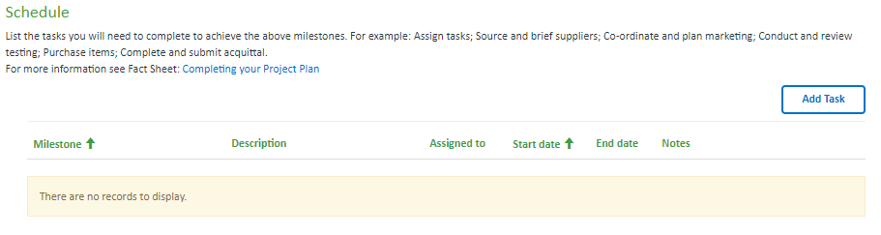
A pop-up-box will open.

Use the search box to select the applicable Milestone and then use text boxes to add the task description, person responsible, dates and any applicable notes, then click ‘Submit’.
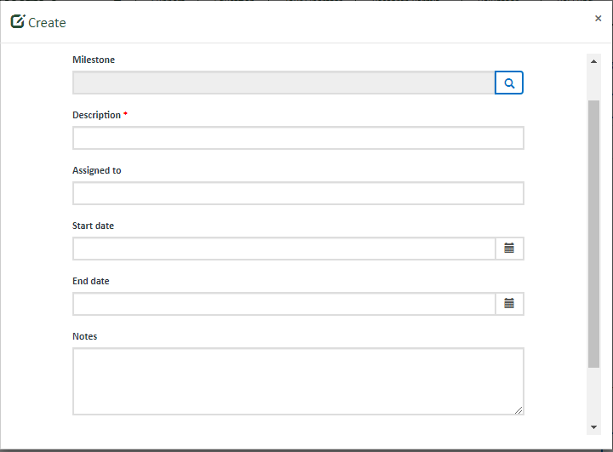

Upon clicking submit, you will return to the project plan. The Task will now show in the table. You can add more items by using the above instructions. You can edit the tasks by clicking on the drop down arrow and selecting ‘Edit’.
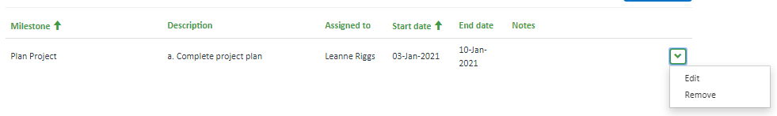
A pop-up-box will open. Use the text boxes to edit the task, person responsible, dates and any applicable notes, then click ‘Submit’.
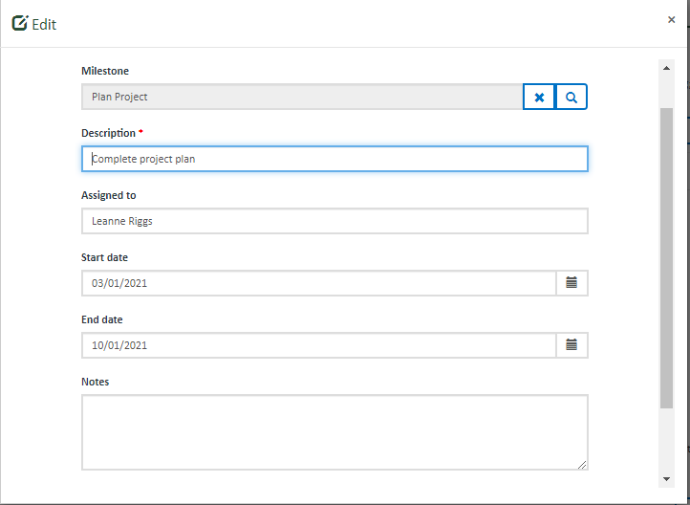

Upon clicking submit, you will return to the project plan. The Task will now show in the table. You can edit more items by using the above instructions.

You can remove a task by clicking on the drop down arrow and selecting ‘Remove’.
Upon clicking Remove, you will return to the project plan. The Milestone will be removed. You can remove more items by using the above instructions.

Once you have filled out all mandatory fields, you can click Save & Exit, Previous or Next to save your project plan.
Save & Exit will save the project plan and exit to the VIF Dashboard. The project plan will be saved as a draft and available in your VIF dashboard to edit, complete and submit. The project plan will only be editable if in draft status (un-submitted). Once the project plan is submitted, the form will become view only.
Previous will save the application and return to the previous page.
Next will save the application and progress to the next page.
The project plan will not save until all mandatory fields are completed (and correct). If any of the mandatory fields are not completed correctly, the errors will list at the top of the page in red. You must correct these errors to save, exit to the VIF dashboard or proceed to the Next page. Your project plan will not save if there are incomplete fields or errors.

Attachments
The Attachments page provides you the opportunity to further demonstrate community support and visuals to assist us better understand your project.

You must upload a copy of your signed Funding Agreement (and any addendums), Certificate of Currency, gantt chart (if the Strategy Section was not completed) and any applicable permits/support. All applicable attachments must be uploaded before Parks Victoria will accept and execute the Funding Agreement. Upload the documents in the relevant category.

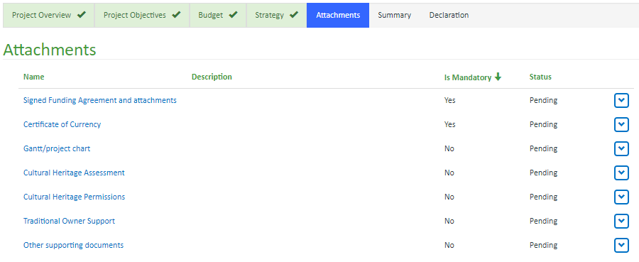

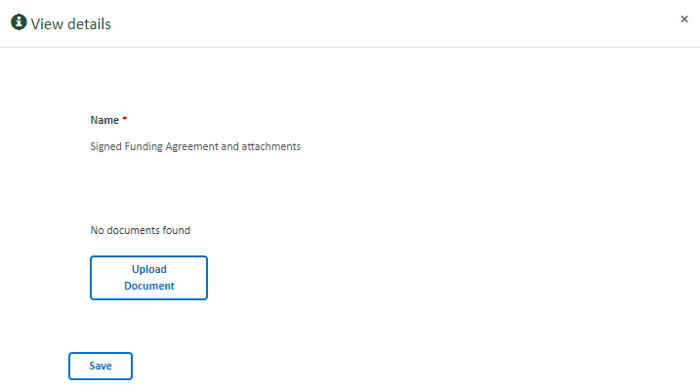
To upload documents, click on the category in blue.

A pop-up-box will open.

Click on the Upload Document button.

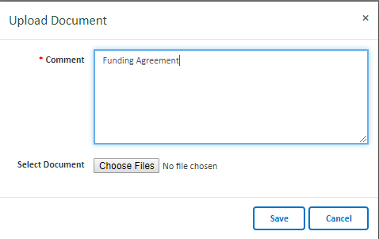

A further pop-up box will open.

Enter the name of the document. The document will not upload
unless this field is completed. This field will assist with
identification of the document.

Click on the Choose Files button.

A pop-up box will open. Select the document and click open. The document will now show here.

Click on the Save button.

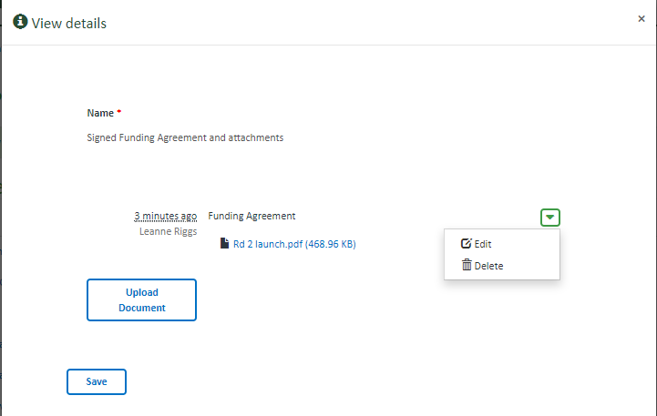
You will return to the View Details pop-up box.

The uploaded document should now show. You can edit or delete
the document by clicking on the drop down arrow.

You can upload more documents to this category by clicking on the
Upload Document button and repeating the above instructions.

Once all documents within this category are uploaded, click on the
Save button.

Upon clicking Save you will return to the project plan. The Status in the table will now show as submitted. You can edit the uploaded documents by clicking on the drop down arrow.

Upload more documents to the other categories by repeating the above instructions.

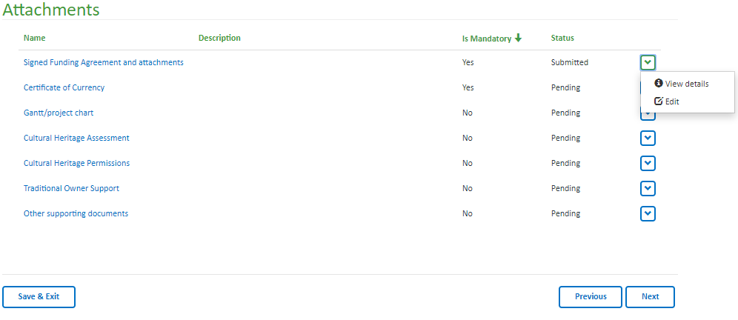

Once you have filled out all mandatory fields, you can click Save & Exit, Previous or Next to save your project plan.

Save & Exit will save the project plan and exit to the VIF Dashboard. The project plan will be saved as a draft and available in your VIF dashboard to edit, complete and submit. The project plan will only be editable if in draft status (un-submitted). Once the project plan is submitted, the form will become view only.
Previous will save the application and return to the previous page.

Next will save the application and progress to the next page.

The project plan will not save until all mandatory fields are completed (and correct). If any of the mandatory fields are not completed correctly, the errors will list at the top of the page in red. You must correct these errors to save, exit to the VIF dashboard or proceed to the Next page. Your project plan will not save if there are incomplete fields or errors.

Summary
The Summary page provides you the opportunity to review your project plan and ensure all fields are answered and correct. You can also print this page.

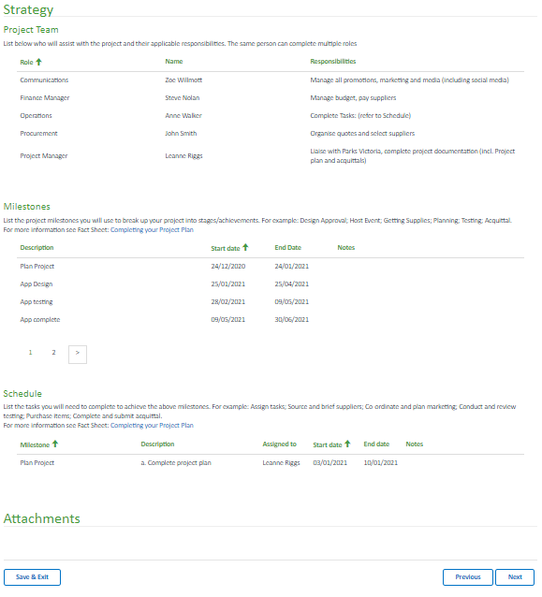
Once you have filled out all mandatory fields, you can click Save & Exit, Previous or Next to save your project plan.

Save & Exit will save the project plan and exit to the VIF Dashboard. The project plan will be saved as a draft and available in your VIF dashboard to edit, complete and submit. The project plan will only be editable if in draft status (un-submitted). Once the project plan is submitted, the form will become view only. Previous will save the application and return to the previous page.

Next will save the application and progress to the next page.

Declaration
The Declaration page confirms your responsibilities when submitting the project plan. You must agree to the declarations to submit the project plan.

If you agree with the declarations, select yes.

The documents checkbox will automatically select dependent on the documents you upload. You will not be able to submit the application unless you have uploaded a copy of your Funding Agreement and Certificate of Currency.

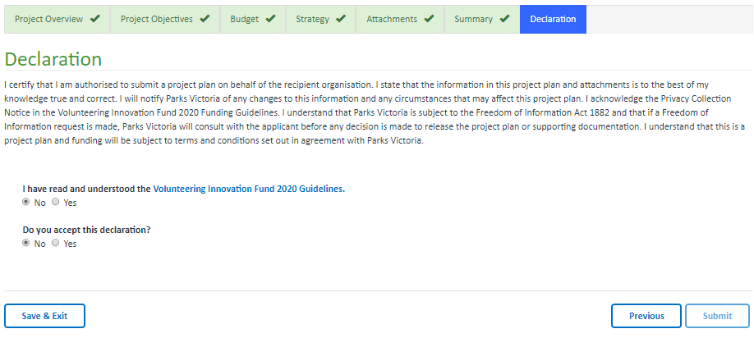

Once you have reviewed the declaration, you can click Save & Exit, Previous or Submit.

Save & Exit will save the project plan and exit to the VIF Dashboard. The project plan will be saved as a draft and available in your VIF dashboard to edit, complete and submit. The project plan will only be editable if in draft status (un-submitted). Once the project plan is submitted, the form will become view only.

Previous will save the application and return to the previous page.

Submit will save the project plan and Submit to us for review. Once submitted you will no longer be able to edit your project plan. Once submitted, the nominated Contact person will receive an email confirming the project plan has been submitted. You can return to the Dashboard to view the project plan at any stage.

