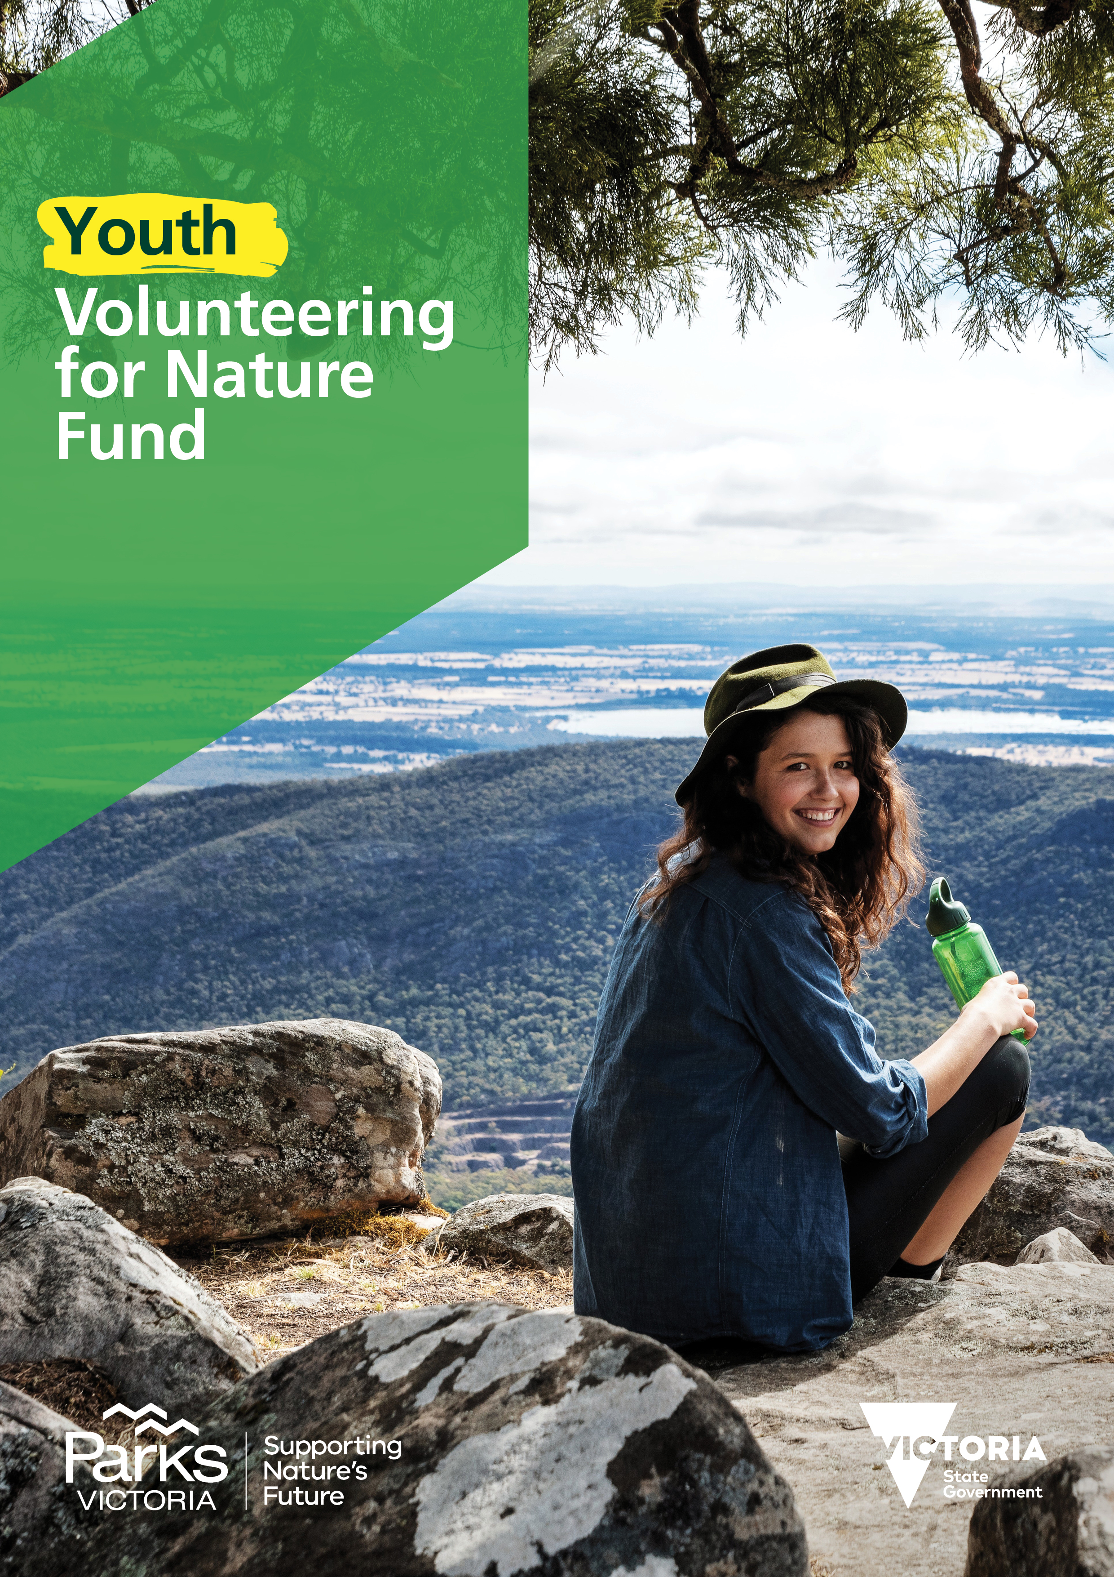

Funding Guidelines v2.1

Contents

What is Youth Volunteering for Nature? 2
Who can apply? 4
What will be included if I am successful? 4
What can be applied for? 5
How do I apply? 5
How will applications be assessed? 7
How are outcomes announced? 8
Handy links 10
Frequently Asked Questions 11
What is the process flow? 13
What are the Terms and Conditions? 14
Acknowledgements 15

What is Youth Volunteering for Nature?
The Youth Volunteering for Nature fund is part of the state government funded Victoria’s Great Outdoors program. We want to empower youth all over Victoria to become champions for nature by creating innovative answers to challenges facing Victoria’s natural environment.
The Youth Volunteering for Nature fund is looking for ideas that engage young people in the community through environmental volunteering to protect and preserve these special places for future generations.

Closes
Spring 2022

August 2022
Youth Volunteering for Nature opens
Summer 2023
Youth Volunteering for Nature announced

Details:
Opens | 9:00am Friday 26th August 2022
Closes | 5:00pm Monday 17th October 2022
Award package | up to $2,000 per project for individuals  up to $5,000 per project for groups  plus: 6-month mentoring; workshops; and program events
Location | Crown land (Victoria)
Eligible projects | Innovative projects that benefit Victoria’s environment, heritage, and legacy through volunteering.
Eligible applicants | Individuals aged 18-29 years old  Groups that that will encourage more young people (18-29 years) to volunteer for nature
Outcomes announced | January 2023
Projects completed by | 6 months
* see pages 4-16 for detailed information

Who can apply?
The Youth Volunteering for Nature fund is open to individuals aged between 18-29 years old and Groups who will encourage more young people, to volunteer for nature; who are residing in Victoria, Australia.
For Groups to be eligible, they must adhere to the following eligibility requirements:
Eligible: | Ineligible:
☐ Bank Account | ☐ Local Governments  ☐ State and Federal government departments  ☐ Applicants who have overdue funding agreements and/or reporting requirements with Parks Victoria

What will be included if I am successful?
As a successful applicant you will be awarded:
- Up to $2,000 to support individuals for their project idea
- Up to $5,000 to support groups for their project idea
- 6-month mentoring with experts in fields of interest (flora/ fauna/ marine/ terrestrial/ Traditional Owner cultural heritage/ post-colonial heritage)
- Initial event welcoming all successful applicants, which comprises of:
  - Opportunities to share your ideas, brainstorm, and network.
  - Guest speakers to develop your knowledge and understanding of:
    - Volunteer program management (including volunteer recruitment)
    - Marketing and communications
    - Presentations from Parks Victoria specialist staff, such as field rangers, community engagement rangers and scientists
- Workshops on Aboriginal cultural heritage, pathways to employment and other relevant topics
- Project support from the Parks Victoria Statewide Volunteer Team
- A final celebration event with the other successful applicants and staff to:
  - Present the outcomes and learnings from your project to Parks Victoria and Department of Environment, Land, Water and Planning (DELWP) staff and the wider community
  - Celebrate your achievements
  - Share your experience

What can be applied for?
Funding is available for a broad range of innovative projects that benefit the Victorian environment.

We are looking for innovative project ideas that address the following selection criteria:
- Champion environmental volunteering through new methods, ideas, items, events, or services;
- Have a positive impact on Victorian biodiversity, environmental, historic and/or Aboriginal cultural heritage values;
- Encourage more young people to volunteer for nature; and
- Provide lessons for the future

When designing your project and addressing the assessment criteria you may like to include ideas that also:
- Foster inclusion, belonging and diversity among young people
- Create meaningful authentic connection between young people and the environment
- Support wellbeing, mental and physical health, and increase understanding of the benefits of a connection to nature
- Raises awareness of environmental and biodiversity issues youth care most about and puts these ideas into action
- Develop knowledge and skills, creating meaningful pathways to employment

What won’t be funded?
We encourage you to be innovative and consider how this award will assist you achieve your project outcomes, however we won’t be funding:
☐ Projects already underway  ☐ Projects conducted on private land/reserves/estates  ☐ Projects that do not involve environmental volunteering | ☐ Projects conducted on local council land/reserves/estates  ☐ Capital Works projects  ☐ Salaries/ wages
Strategic Alignment
The Youth Volunteering for nature fund aligns with two important Strategies;
Protecting Victoria’s Environment - Biodiversity 2037
Protecting Victoria’s Environment – Biodiversity 2037 is the Victorian State Government’s policy response to addressing the decline in biodiversity. The Biodiversity Plan presents a long-term vision for Victoria’s biodiversity supported by two goals:
- Victorians Value Nature, and
- Victoria’s natural environment is healthy.
Specific targets have been developed to deliver on these goals, and 20 priorities have been identified to guide actions. Conservation actions delivered through the plan will be more strategic, deliver better value for money and will be underpinned by the best available science to ensure efforts deliver the most benefit for the most species

Victorians Volunteering for Nature - Environmental Volunteering Plan
Supporting, improving and expanding the environmental volunteering sector in Victoria will contribute directly to the vision and goals of Biodiversity 2037. Of particular relevance is the target of five million Victorians acting to protect the natural environment by 2037.
The Youth Volunteering for Nature Fund aims to encourage and inspire more young people to participate in environmental volunteering to help reach this target.

How do I apply?
Applications need to be submitted online through ParkConnect. If you haven’t already, you will need to register an account. Use the below link to register and start your application:
https://www.parkconnect.vic.gov.au/yif/
You will receive an application number after you apply online. Please quote this number in all communications with Parks Victoria relating to your application. All applications need to be submitted by the due date. Late and incomplete applications will not be considered.
If you require assistance, please call the helpline on:
13 1963 or email volunteer@parks.vic.gov.au

What needs to be included in my application?
Below is a table of the application requirements.
Requirements
Application form | - Completed in full  - Filled out correctly  - Submitted on-line before the cut-off date and time
Approvals/written support | ☐ Land manager  ☐ Traditional Owner Corporation (if within jointly managed land https://www.parks.vic.gov.au/managing-country-together)
Supporting Documentation | - Video under 50 mb (non-mandatory)  - Documents under 3mb in file size  - Maximum of 7 files  - File formats:  - MS Word  - MS Excel  - PDF  - JPEG

How will applications be assessed?
All applications will be assessed by a panel of independent assessors on 4 criteria. Each assessor will score applications with a score between 1-7 for each criterion. Scores are then calculated, producing a ranking list of all applications. Projects that address Protecting Victoria’s Environment -Biodiversity 2037 targets will be preferenced. The top scoring applications will be awarded successful.

Biodiversity
Does the project include the following activities?
- Habitat restoration and/or revegetation
- Weed control
- Scientific research
- Predation control
Does the project address the following themes?
- Threatened species
- Threatened communities
- Biodiversity threats
- Predation (predator and herbivore)

The four criterions are below:
MERIT
Weight = 20%
VOLUNTEERISM
Weight = 40%
Weight = 30%

Description
What are the overarching benefits
of the project?
Other elements
- What are the environmental benefits of the activity
- What are the social, cultural heritage and/ or historic heritage benefits?

Description
Does the project inspire more young people to improve the environment through volunteering?
Weight = 30%

Other elements
- Will the project increase the:
- Number of young volunteers participating in environmental volunteering for the first time
- Diversity of people volunteering

- Will the project improve:
- Young people’s understanding of and interest in the environment and volunteering
- Inclusivity and accessibility for volunteers

INNOVATION
LEGACY
Weight = 10%
Description
How innovative is the project?
Other elements
- How well does the project address the following definition; Something new or different that creates value for the environment and volunteering?
- Does the project develop new and different approaches currently not offered that would benefit the environment?
Description
Will the project leave a legacy?
Other elements
- Can the project be continued in the future?
- Can the project provide lessons for the future?

How are outcomes announced?
The outcomes of each application will be announced by Round. Successful applications will be announced publicly. Each applicant will receive an email from ParkConnect advising of the outcome. This can take up to 1 week. Outcomes will take the following timeframes:
Amount: $2,000 for individuals or $5,000 for groups
Outcome timeframe: 4 months

Assessment
2 weeks
Approvals
3-6 weeks
Applications close/ application collation
2 weeks
Applications Open
6 weeks
Announcement of successful applicants
1 week

End of Project Reporting
Project completion and reporting must be submitted 6 months from date of funding payment transferred by Parks Victoria

I’m successful, where to next?
Successful applicants will receive an Award Pack consisting of the following:
- Success letter
- Instructions
- Letter of Agreement
- Project Plan (available in ParkConnect)
- End of Project Report (available in ParkConnect)
Any documentation which needs to be signed must be submitted by the notified due date.
Projects must be managed and completed by the applicants, and end of project reports submitted by the due date.

What other documentation will I be required to provide if my application is successful?
All required documentation will be specified in the Award Pack. Successful recipients will be required to submit the following applicable documents:
Mandatory: | If applicable:
☐ Letter of Agreement and attachments  ☐ Job Safety Plan (attach to ParkConnect profile)  ☐ Working with Children Check  (attach to ParkConnect profile) | ☐ Gantt chart  ☐ Cultural Heritage Assessment  ☐ Cultural Heritage Permissions  ☐ Traditional owner support  ☐ Permits  ☐ Accreditations/licences/competencies  (attach to ParkConnect profile)

Can I change my project after submitting the application?
If it is determined that you cannot complete the project (as applied for) before being notified of outcomes, you must withdraw your application.
If the project has been notified of success and is underway and it is later determined that the project scope needs to change, you must contact Parks Victoria to discuss these changes prior to making any variations.

How do I close my project?
Upon completion of your project, an end of project report with all required supporting documentation must be submitted. This can only be submitted once your project is complete. Parks Victoria will review and respond within 4 weeks. Further information on how to complete an end of project report will be provided to you in your award pack if you are successful.

What happens if my application is unsuccessful?
Unsuccessful applicants will have the ability to request feedback within 14 days of being notified. Feedback can assist you to complete future applications. You can also re-apply to future rounds, including the preceding round.

Lodging Grievances
If you would like to lodge any grievances regarding the outcome of your application, please submit a signed letter to:
Email:  Or,  Mail to: | volunteer@parks.vic.gov.au  Statewide Volunteer Manager Parks Victoria  Level 10, 535 Bourke Street Melbourne VIC 3000

Handy links
Park Web: www.parks.vic.gov.au/get-into-nature/volunteering/youth-volunteering-for-nature
ParkConnect: https://www.parkconnect.vic.gov.au/yif
Protecting Victoria’s Environment – Biodiveristy 2037: https://www.environment.vic.gov.au/biodiversity/biodiversity-plan
Victorians Volunteering for Nature – Environmental Volunteering Plan: https://www.environment.vic.gov.au/__data/assets/pdf_file/0035/394883/VVfN-Environmental-Volunteering-Plan_WEB.pdf

Frequently Asked Questions

How much can I apply for?
You can apply for up to $2,000 for individuals and $5,000 for groups in funding for your project as part of the award. You will need to demonstrate how this money will be spent through submitting a budget plan if you are successful.

Can I apply for funding for the whole project?
Applications to fund the project in part and in full will be accepted.

Where can I hold my project?
Your project can take place in parks, forests, and reserves on Crown Land across the state of Victoria, both marine and terrestrial. Projects may also take place virtually, or a combination of both.

How do I find out who I need to speak to about approval for my project?
If you are submitting an application which includes any works on Crown Land, you need support from the land manager. In most cases this will be the Parks Victoria Area Chief Ranger. Where the project is in a jointly managed park, this must include support from the Traditional Owner Corporation. You can find a list of jointly managed parks here: https://www.parks.vic.gov.au/managing-country-together
Approval can be shown in the way of a letter or email and uploaded in the supporting documents section of your application.
If you are unsure how to contact your Area Chief Ranger, please contact the Volunteering for Nature Fund Team to connect you.

Do I need Traditional Owner approval for my project?

You may need Traditional Owner approval prior to commencement of your project. If the project requires ground disturbance (e.g. tree planting) then a cultural heritage assessment may be required.

Do not approach Traditional Owners directly unless you have an existing partnership arrangement. Parks Victoria and Department of Environment, Land, Water and Planning will broker conversations between applicants and Traditional Owners as appropriate. Contact the Youth Volunteering for Nature Fund Team to initiate engagement.
For further details on both topics read our Managing Country Together fact sheet.

How do I create my application video?
Any way you like! You can film it on your phone or create it on a platform such as WeVideo. You don’t need to be a skilled film maker – it’s the content and message that are important, not the quality of the video.

What if I can’t make a video?
That’s ok too! You can describe your idea in writing in the application form.

Can I apply in a group?
Yes, this program is for individuals and groups. The goal of the award is to support young leaders to implement their vision for environmental volunteering, whilst also developing skills they can use in the future.
Exceptions may apply in some circumstances. If you feel that you may qualify for an exception, please contact us at volunteer@parks.vic.gov.au.

How many volunteers do I need to join my project?
It is important that your project engages other young people to volunteer for nature, and this will assist you in successfully completing your project. As all projects are different there is no set number of volunteers that are required to be involved in the project. Read the criteria carefully as you will need to explain how your project increases environmental volunteering. This may be through large numbers of volunteers, however it could also be through increasing diversity or accessibility. The size and population of the region your project is located in will also be taken into consideration.

What is the difference between cultural heritage and historic heritage?
Cultural heritage refers to Aboriginal heritage, such as artefacts, architecture, art, traditional practices and living culture. Historic heritage refers to post-colonial heritage, such as buildings and structures, significant trees, gardens, landscapes, archaeological sites, a large collection of objects, and shipwrecks.

When are outcomes announced?
Outcomes will be announced approximately 4 months after the closing date.

Will I need to sign an Agreement?
Successful applicants will be required to enter into an agreement with Parks Victoria, outlining the requirements of both the recipient (you) and the grantee (Parks Victoria).
A Letter of Agreement will be used. Parks Victoria may add additional conditions, dependent on the scope of the approved project.

When do the projects have to be completed by?
Successful applicants are required to complete their projects and submit acquittals within 6 months from the deposit of funding from Parks Victoria.

Will I need to report on my project outcomes?
If your application is successful you will need to document your project with pictures and/or videos and share these with Parks Victoria.

You will also need to report your volunteering activities and events in the volunteer portal ParkConnect.

At the final event you will share your experience and outcomes with the group.

Should I promote my project?
Yes! We want you to spread the word about the great work you are doing. You can involve the public throughout and at the completion of your project. If successful, promotional guidelines will form part of the Letter of Agreement.

Will I need a Working with Children Check?
Yes. All Parks Victoria volunteers require a valid volunteer Working with Children Check. This is a simple, free process for volunteers. To apply for a volunteer Working with Children Check click here.

What is the process flow?
The below diagram demonstrates the flow of applications from submission to completion.
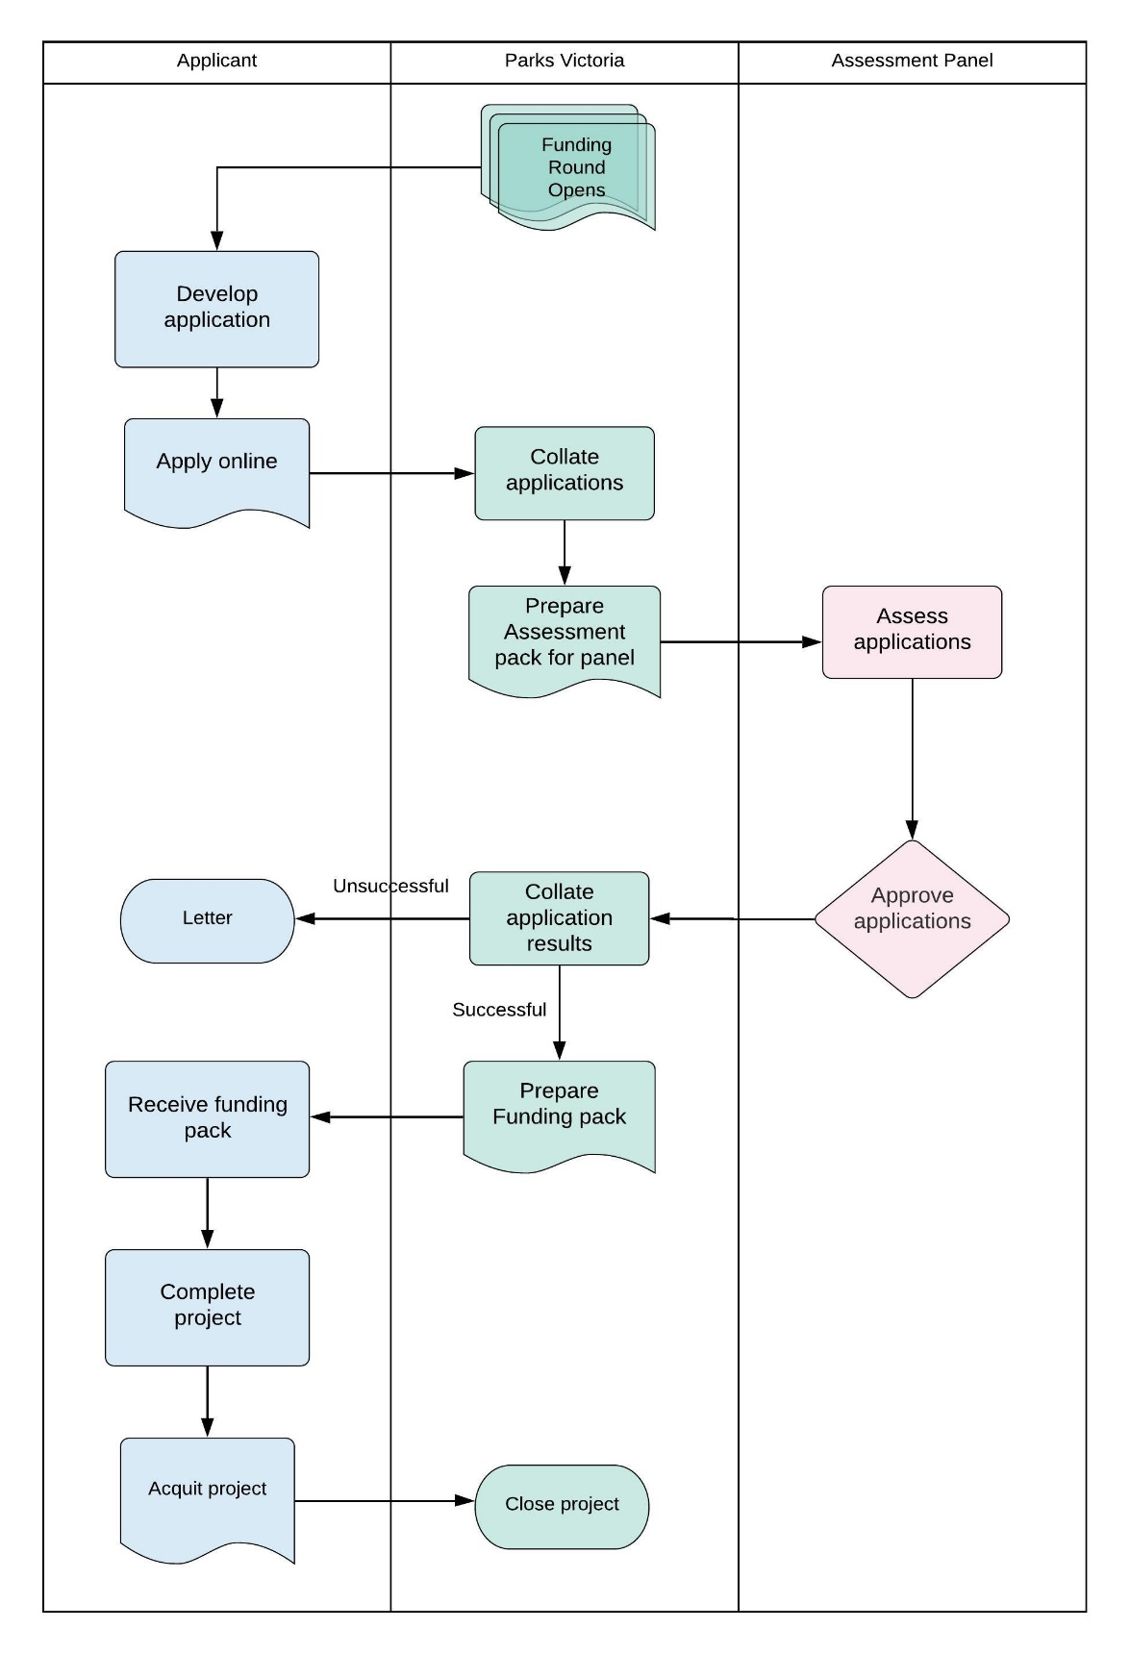

What are the Terms and Conditions?
The following conditions will apply to successful applicants:
- Accept a Letter of Agreement detailing the requirements and expectations of the Fund.
- Work on Crown land requires land manager consent. Support can be given based on discussions with your local Parks Victoria/Department of Environment, Land, Water and Planning Officer. Recipients are responsible for obtaining all necessary permits, approvals, and consents prior to the commencement of any works.
- Projects must commence within one (1) month of entering into the Letter of Agreement with Parks Victoria. Projects that have not commenced within this timeframe must contact the Fund team to explain the delays and negotiate an appropriate commencement date. Recipients that fail to provide this advice may risk voiding the Letter of Agreement and may have to return any funds provided.
- Project activities must be entered in to ParkConnect and all volunteers need to register their participation
- Projects must be completed, and acquittals submitted within 6 months from deposit of funding from Parks Victoria.
- Funds must be spent on the project as described in the application and any unspent funds must be returned to Parks Victoria, as per the Letter of Agreement.
- Additional project costs must be funded by the applicant.
- Any variation to the approved project must be submitted to Parks Victoria for approval prior to implementation.
- Acknowledgement of the Victorian Government’s support: Promotional guidelines will form part of the agreement.
- Successful applicants must liaise with the Volunteer team to coordinate any public events or announcements related to the project.
- Contribute information on activity outcomes for use in program evaluation reviews or the department’s marketing materials.
- Submit reports detailing the progress and outcomes of the award as per the Letter of Agreement.
- Complete and provide a project acquittal and any other completion reports required.
- Project must adhere to all applicable Parks Victoria volunteering management policies and procedures, including the use of ParkConnect.

Acknowledgements
By applying, the applicant acknowledges that:
- Youth Volunteering for Nature Funding Guidelines have been read and understood.
- Individuals are between the ages of 18-29 at time of application.
- Groups are engaging young people in an eligible volunteer project
- All information provided within your application is correct - providing any false or misleading information may result in the rejection of the application.
- PV may seek to confirm any information contained in your application and may request additional information. Failure to provide the information may mean that the application is unable to be assessed and result in the rejection of the application.
- If successful, details of the project may be made public on the Parks Victoria or other vic.gov.au website.
- The applicant and lessee of the property agree to allow Parks Victoria to use or publish any photographs supplied for the purposes of promotion on the Parks Victoria website, intranet and social media accounts, or in any printed material or media.
- They recognise Parks Victoria is collecting your personal information (such as your name and contact details) and supporting material in order to assess your eligibility for funding and contact you about your application. Your information will be held and managed in accordance with the Privacy and Data Protection Act 2014 and the Public Records Act 1973.
- Personal information about you or a third party in your application will be collected by Parks Victoria for the purpose of administration. This information may be provided to other Victorian government bodies for the purposes of assessing your application. If you intend to include personal information about third parties in your application, please ensure they are aware of the contents of this privacy statement.
- Any personal information about your or a third party in your correspondence will be collected, held, managed, used, disclosed, or transferred in accordance with the provisions of the Privacy and Data Protection Act 2014 and other applicable laws
- Parks Victoria is committed to protecting the privacy of personal information. You can find the Parks Victoria Privacy Policy online at www.parks.vic.gov.au/privacy Requests for access to information about you held by Parks Victoria should be emailed to info@parks.vic.gov.au, or sent to Parks Victoria, Level 10, 535 Bourke Street, Melbourne VIC 3000 or made by phone to 13 19 63. Information and uploaded images and documentation in this application is stored on departmental systems.

