Before applying
Make sure you have read the Fact Sheet: Building your Application and have support for the project from all required before submitting. Keep copies of your application including supporting documentation. This information can be used for future applications or to assist with queries should your application be successful.

Once submitted, your application will be collated with all other applications to the relevant Round and tendered for assessment and scoring.

When applying

1. Register with Park Connect
To apply, you will need to register with Park Connect.
If you have previously registered, you will be able to access the Volunteering Innovation dashboard and application form.
Username and password
Upon registering, you will be emailed a username (email address) and password. Record this information somewhere safe.

2. Complete the application
The application form can be saved as you go. You can click through the sections and submit or save a draft. You can access and submit draft applications through your Volunteering Innovation Fund dashboard.
You must answer all fields before submitting your application. If fields are left blank, your application may:
- be ineligible
- score lower
- not submit

* denotes mandatory fields. If these fields are left blank, the application form will not save or allow you to move to the next or previous page.

Use the screen shots below to assist completing your application.

3. Submit the application
Once you have answered all fields and uploaded all attachments you can submit your application. Once submitted, you are unable to make any edits/changes. You can view your submitted application through your Volunteering Innovation Fund dashboard.

Contact us
If you have any queries, or require more information, please contact Parks Victoria via: email: VolunteeringFund@parks.vic.gov.au or phone: 1300 375 323

Access the Volunteering Innovation Fund
To access the Volunteering Innovation Fund information click on the below icons on the ParkConnect home page:
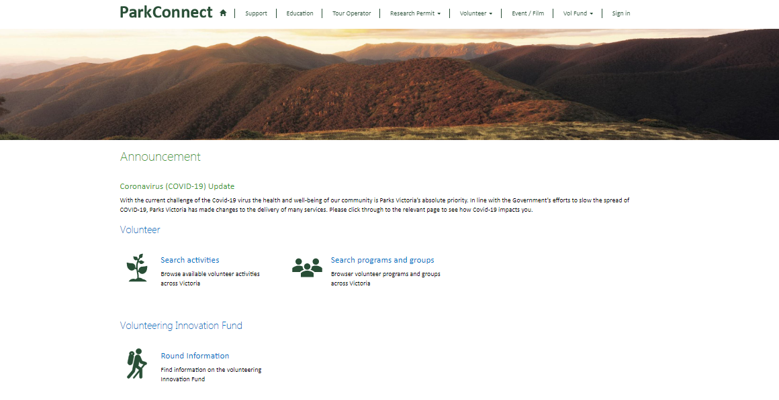
You will be taken to the Volunteering Innovation Fund (VIF) landing page. If you have not registered with ParkConnect, you will need to, to access the VIF Dashboard and application form. You can access the registration page, VIF dashboard and application form through the blue outlined buttons, or through the top navigation bar.
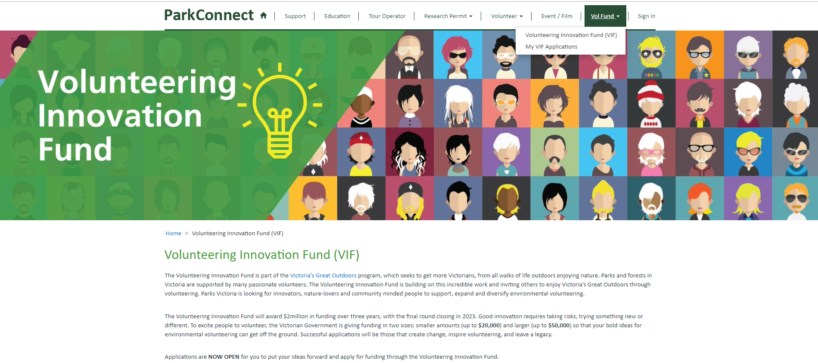

You can access the Funding Guidelines and Fact Sheets on the landing page through the following links. You can also find them on www.parkconnect.vic.gov.au/vif

The VIF dashboard allows you to commence and manage your applications. You can start a new application by clicking the blue outlined button on the landing page or on your VIF dashboard.

All your draft and submitted applications will be accessible through your VIF dashboard. If you save a draft application, you can access it to review, edit, proof read, submit or delete by clicking on the Application ID or the drop down arrow.
Once you have submitted an application you are unable to edit. The application will become ‘view only’.

Start an Application
To start a new application, click on the “Start Application” button on the landing page or your VIF dashboard. The button will take you to the first page of the application.

Applicant Details
The Applicant is the entity applying for funding. This can be the name of the Group, Organisation, Club, individual etc. e.g. xyz Volunteer Group.
You will only be required to enter your ABN if you answer ‘yes’ to the previous question. If you do not have an ABN, you will need an auspice. Attach a copy of your ABN in the documents page at the end of the form.

You will only be required to enter the public liability amount if you answer ‘yes’ to the previous question. If successful, you (or your auspice) must effect and maintain public liability insurance for at least $10,000,000.
If you are not incorporated you will need an auspice.
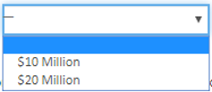

If you do not have an ABN, and/or are not incorporated and/or not willing to effect and maintain public liability insurance for at least $10,000,000, you will need an auspice. See Fact Sheet: Auspice of Projects for more information.
You will need to provide the name, position and contact details for a nominated Contact person. This person will answer all queries in relation to the application.
You will need to provide the name, position and contact details for the person authorised to sign the Funding Agreement (should the application be successful). This person should be the CEO, president or equivalent or an authorised delegate.
If this is the same person as the Contact, tick the box to copy all the information over.
If you selected ‘yes’ to auspice, the below section will show. If you do not require an auspice, move through to ‘Applicant Overview’.
If you require an auspice, complete the Auspice Details and Auspice Authorised Representative Details section and attach a copy of their ABN in the documents page at the end of the form.

You will need to provide the name, position and contact details for the person from the auspice entity authorised to sign the Funding Agreement (should the application be successful). This person should be the CEO, president or equivalent or an authorised delegate.
If this is the same person as the Contact, tick the box to copy all the information over.

The Applicant Overview section provides you the opportunity to tell us who you (your group/organisation/club/entity) are and what you do. If you are ‘in establishment’ or ‘looking to initiate’ answer the questions with what is proposed/planned.
Where are your Head Quarters located? Use the link to identify the area.

List all the activities, roles and functions performed by you (your group/organisation/club/entity).
Do you (your group/organisation/club/entity) already engage with volunteers? If yes, answer the three questions on the right hand side.
Specify the total volunteering hours for the applicant (group/organisation/club/entity). Please do not just include your own hours.
Environmental volunteering refers to volunteering in and for our natural environment (including cultural values and heritage).

Crown Land refers to public land managed by Parks Victoria, Department of Environment, Land, Water and Planning, and Committees of Management. Select ‘no’ if you (your group/organisation/club/entity) do not currently interact with visitors.

Provide an overview of your group/organisation/club/entity so we can better understand your background, values and mission.

Once you have filled out all mandatory fields, you can click Save & Exit or Next to save your application.
Save & Exit will save the application and exit to the VIF Dashboard. The application will be saved as a draft and available in your VIF dashboard to edit, complete and submit during the round opening dates. The application will only be editable if in draft status (un-submitted) and while the Round is open. Once the application is submitted and/or the Round closes, the application will become view only.
Next will save the application and progress to the next page.
The application will not save until all mandatory fields are completed (and correct). If any of the mandatory fields are not completed correctly, the errors will list at the top of the page in red. You must correct these errors to save, exit to the VIF dashboard or proceed to the Next page. Your application will not save if there are incomplete fields or errors.

Project Overview
The Project Overview page provides you the opportunity to tell us about your project.

Use the link to identify the area/s.

Click the button to add one or more project areas.

A pop-up-box will open. Select the applicable area/s from the list and then
click Add.

Upon clicking Add (or Cancel) you will return to the application form. The selected areas will now show in the table.
You can remove areas by clicking on the drop down arrow and selecting Remove.
You can add more areas by using the above instructions.
Use the link to identify the Traditional Owners.

Click the button to add one or more Traditional Owners.

A pop-up-box will open. Select the applicable Traditional Owner/s from the list and then click Add.
If there are no Traditional Owners formally recognised in the area, select
this option.

Scroll through all the Traditional Owners using the bar and list pages.

Upon clicking Add (or Cancel) you will return to the application form. The selected Traditional Owners will now show in the table.
You can remove Traditional Owners by clicking on the drop down arrow and selecting Remove.
You can add more Traditional owners by using the above instructions.

Use the link to identify jointly managed parks. For more information see Fact Sheet: Managing Country Together

You must have support from land manager/s before applying. Written support must be attached in the documents page at the end of the form. For more information see Fact Sheet: Building your Application.

Click on the calendar icon to enter a date.
Projects must be completed within 12 months from receipt of funding from Parks Victoria. Make sure the project dates align with the Volunteering Innovation Fund timelines.

Provide an overview of the project so we can better understand the background, scope and outcomes of the project.

Once you have filled out all mandatory fields, you can click Save & Exit, Previous or Next to save your application.
Save & Exit will save the application and exit to the VIF Dashboard. The application will be saved as a draft and available in your VIF dashboard to edit, complete and submit during the round opening dates. The application will only be editable if in draft status (un-submitted) and while the Round is open. Once the application is submitted and/or the Round closes, the application will become view only.
Previous will save the application and return to the previous page.
Next will save the application and progress to the next page.
The application will not save until all mandatory fields are completed (and correct). If any of the mandatory fields are not completed correctly, the errors will list at the top of the page in red. You must correct these errors to save, exit to the VIF dashboard or proceed to the Next page. Your application will not save if there are incomplete fields or errors.

Assessment Criteria
The Assessment Criteria page provides you the opportunity to show us how your project meets the Volunteering Innovation Fund objectives and assessment criteria.
You can find a copy of the assessment criteria in the Funding Guidelines.

Innovation is weighted as 40% of our total score.

You must select one or more of the below objectives.
You can find more information on the Victorians Volunteering for Nature, Environmental Volunteering Plan here (or go to www.environment.vic.gov.au/victorians-volunteering-for-nature).
Volunteerism is weighted as 30% of your total score.

Legacy is weighted as 10% of your total score.

Merit is weighted as 20% of your total score.

Applicants are encouraged to look at Traditional Owner Country Plans, where available, and consider projects that align with Traditional Owner objectives. The ACHRIS Welcome Map (https://achris.vic.gov.au/weave/wca.html) can be used to determine whether there are recognised Traditional Owners in the project area. Where appropriate, successful applicants will be expected to engage with Traditional Owners prior to projects starting. Conversations will be brokered by Parks Victoria and Department of Environment, Land, Water and Planning upon notification of project success. For more information see Fact Sheet: Managing Country Together.
Applications that include partnerships with other entities will be highly regarded.
To add partners select yes, choose the number of partners from the drop down box and then click on the Add Partner button.

A pop-up-box will open. Enter the applicable information in the fields and then click Submit.
You must enter a name for each partner.
The location information will assist us understand the community support of your project.
The partners involvement will assist us better understand the scope, responsibilities and community support of your project.

Upon clicking Submit you will return to the application form. The partner will now show in the table.
You can add more partner by using the above instructions.
You can remove partners by clicking on the drop down arrow and selecting Remove.
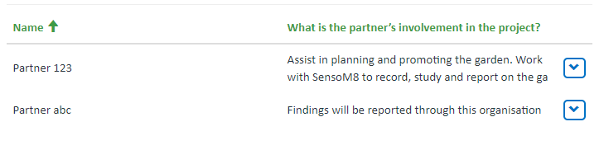

Once you have filled out all mandatory fields, you can click Save & Exit, Previous or Next to save your application.
Save & Exit will save the application and exit to the VIF Dashboard. The application will be saved as a draft and available in your VIF dashboard to edit, complete and submit during the round opening dates. The application will only be editable if in draft status (un-submitted) and while the Round is open. Once the application is submitted and/or the Round closes, the application will become view only.
Previous will save the application and return to the previous page.
Next will save the application and progress to the next page.
The application will not save until all mandatory fields are completed (and correct). If any of the mandatory fields are not completed correctly, the errors will list at the top of the page in red. You must correct these errors to save, exit to the VIF dashboard or proceed to the Next page. Your application will not save if there are incomplete fields or errors.

Budget
The Budget page provides you the opportunity to show us everyone contributing to the project and how you will manage the funding.
Make sure you provide the correct number of quote/s when submitting your application. It is important to have accurate quotes because if successful projects have costs more than quoted, there is no extra funding to help you cover these costs. Where possible source quotes from: local suppliers; Aboriginal business or Social Enterprise; and suppliers who demonstrate environmentally sustainable business practices.

Complete the project costs as GST exclusive amounts.
In-kind contribution is all effort that is volunteered towards the project, including transport, administration, field activities and promotion. Calculate the in-kind contribution at $38 per hour, per volunteer (e.g. Vol1 - 10hours + Vol2 - 20hours = 380+760 = $1,140).
The total will automatically calculate as you enter amounts into the fields.

To add budget Items click on the Add Item button.

A pop-up-box will open. Enter the item and amount in the fields and then click Submit.
The budget breakdown will assist us score the Merit criteria of your project.

Upon clicking Submit you will return to the application form. The item will now show in the table.
You can add more items by using the above instructions.
You can remove items by clicking on the drop down arrow and selecting Remove.
Use the list pages to move through all submitted items.

Parks Victoria is responsible for protecting Aboriginal cultural heritage values on the parks estate. All projects that include ground disturbance (including tree planting) must undertake a cultural heritage assessment to determine the risk to Aboriginal heritage prior to the activity starting. For more information see Fact Sheet: Managing Country Together.

If your project includes the opportunity to make income, select yes and answer the following questions.

Once you have filled out all mandatory fields, you can click Save & Exit, Previous or Next to save your application.
Save & Exit will save the application and exit to the VIF Dashboard. The application will be saved as a draft and available in your VIF dashboard to edit, complete and submit during the round opening dates. The application will only be editable if in draft status (un-submitted) and while the Round is open. Once the application is submitted and/or the Round closes, the application will become view only.
Previous will save the application and return to the previous page.
Next will save the application and progress to the next page.
The application will not save until all mandatory fields are completed (and correct). If any of the mandatory fields are not completed correctly, the errors will list at the top of the page in red. You must correct these errors to save, exit to the VIF dashboard or proceed to the Next page. Your application will not save if there are incomplete fields or errors.

Documents
The Document page provides you the opportunity to further demonstrate community support and visuals to assist us better understand your project.

You must upload a copy of your (or your Auspice) ABN, land manager support and quotes (if applicable). Failure to upload these documents may deem your application ineligible. For more information see the Funding Guidelines and/or Fact Sheet: Building your Application. Upload the documents in the relevant category.

Please keep attachments to a maximum of 7 only.
To upload documents, click on the category in blue.
A pop-up-box will open.
Click on the Upload Document button.

A further pop-up box will open.
Enter the name of the document. The document will not upload unless this field is completed. This field will assist with identification of the document.
Click on the Choose Files button.
A pop-up box will open. Select the document and click open. The document will now show here.
Click on the Save button.

You will return to the View Details pop-up box.
The uploaded document should now show. You can edit or delete the document by clicking on the drop down arrow.
You can upload more documents to this category by clicking on the Upload Document button and repeating the above instructions.
Once all documents within this category are uploaded, click on the Save button.

Upon clicking Save you will return to the application form. The Status in the table will now show as submitted. You can edit the uploaded documents by clicking on the drop down arrow.
Upload more documents to the other categories by repeating the above instructions.

Once you have uploaded all applicable documents, you can click Save & Exit, Previous or Next to save your application.
Save & Exit will save the application and exit to the VIF Dashboard. The application will be saved as a draft and available in your VIF dashboard to edit, complete and submit during the round opening dates. The application will only be editable if in draft status (un-submitted) and while the Round is open. Once the application is submitted and/or the Round closes, the application will become view only.
Previous will save the application and return to the previous page.
Next will save the application and progress to the next page.
The application will not save until all mandatory fields are completed (and correct). If any of the mandatory fields are not completed correctly, the errors will list at the top of the page in red. You must correct these errors to save, exit to the VIF dashboard or proceed to the Next page. Your application will not save if there are incomplete fields or errors.

Summary
The Summary page provides you the opportunity to review your application and ensure all fields are answered and correct. You can also print this page.

Once you have reviewed your application, you can click Save & Exit, Previous or Next.
Save & Exit will save the application and exit to the VIF Dashboard. The application will be saved as a draft and available in your VIF dashboard to edit, complete and submit during the round opening dates. The application will only be editable if in draft status (un-submitted) and while the Round is open. Once the application is submitted and/or the Round closes, the application will become view only.
Previous will save the application and return to the previous page.
Next will save the application and progress to the next page.

Declaration
The Declaration page confirms your responsibilities when submitting the application. You must agree to the declarations to submit the application.

If you agree with the declarations, select yes.
The documents checkbox will automatically select dependent on the documents you upload. You will not be able to submit the application unless you have uploaded a copy of your (or you auspice) ABN.
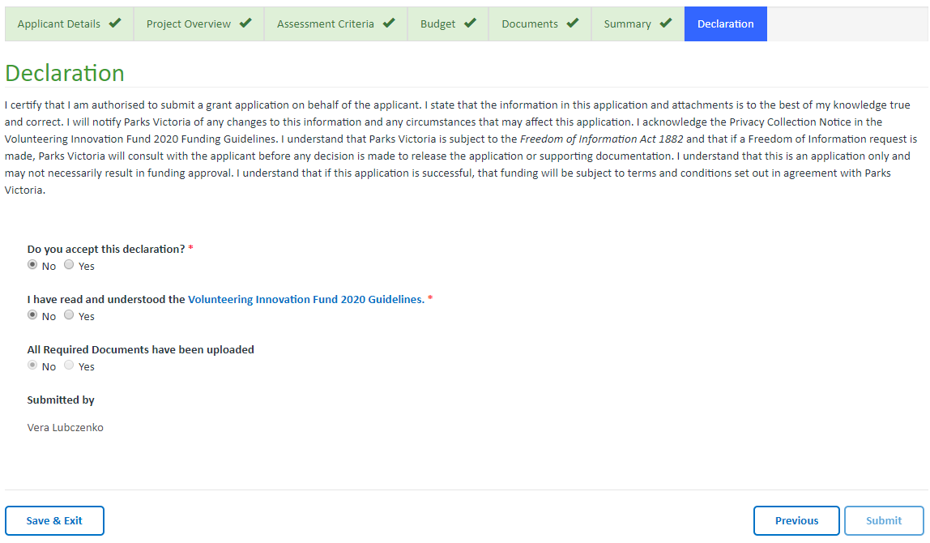

Once you have reviewed the declaration, you can click Save & Exit, Previous or Submit.
Save & Exit will save the application and exit to the VIF Dashboard. The application will be saved as a draft and available in your VIF dashboard to edit, complete and submit during the round opening dates. The application will only be editable if in draft status (un-submitted) and while the Round is open. Once the application is submitted and/or the Round closes, the application will become view only.
Previous will save the application and return to the previous page.
Submit will save the application and Submit to us for assessment. Once submitted you will no longer be able to edit your application. Once submitted, the nominated Contact person will receive an email confirming the application has been submitted. You can return to the Dashboard to view the application at any stage.

