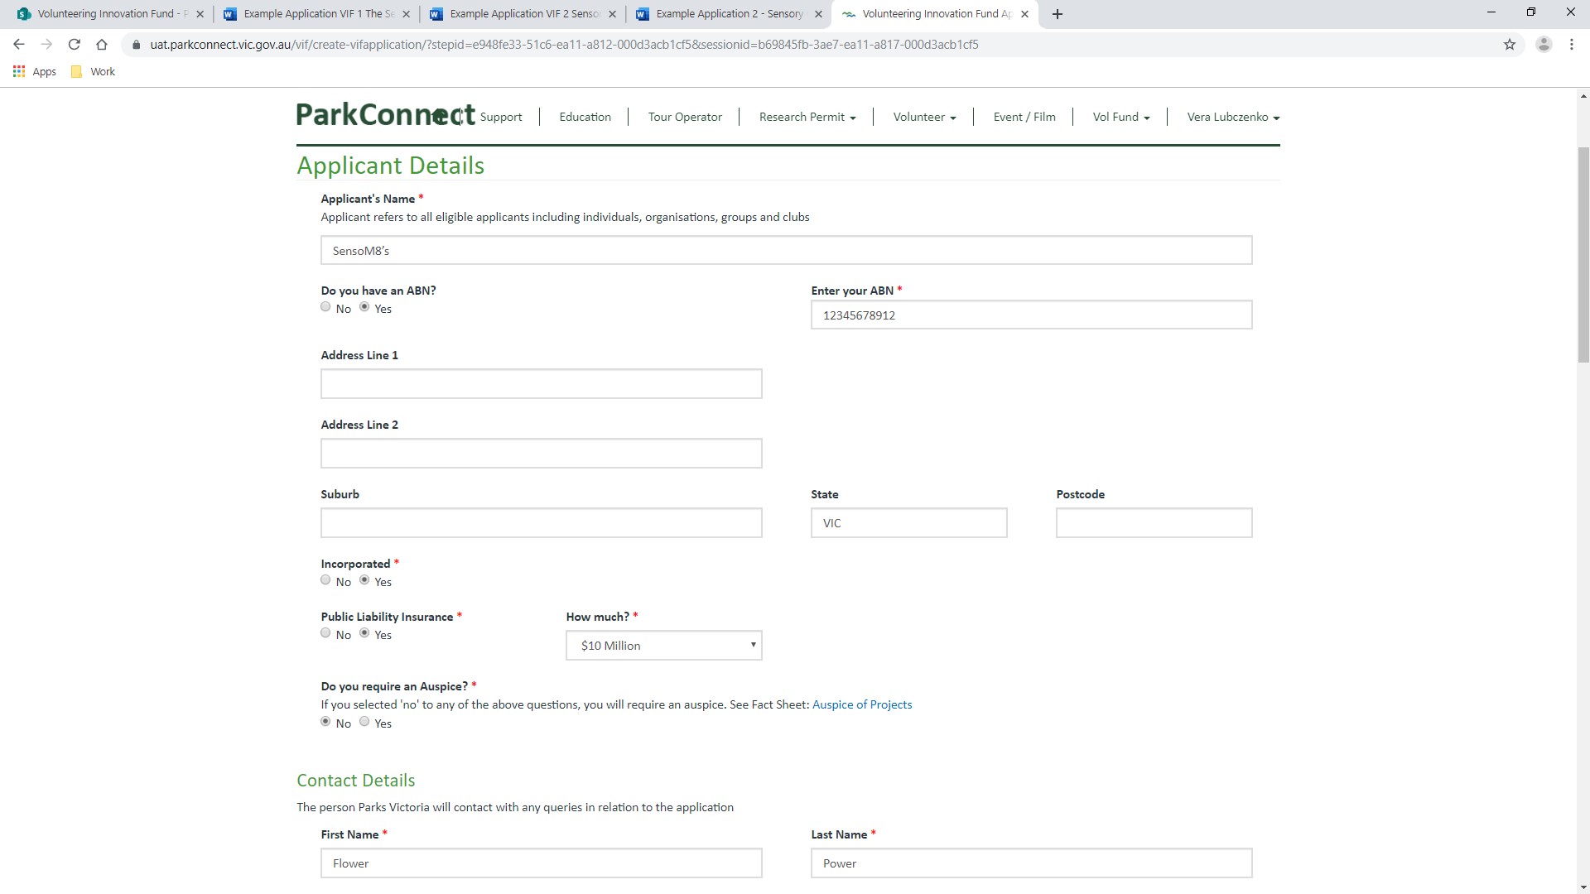

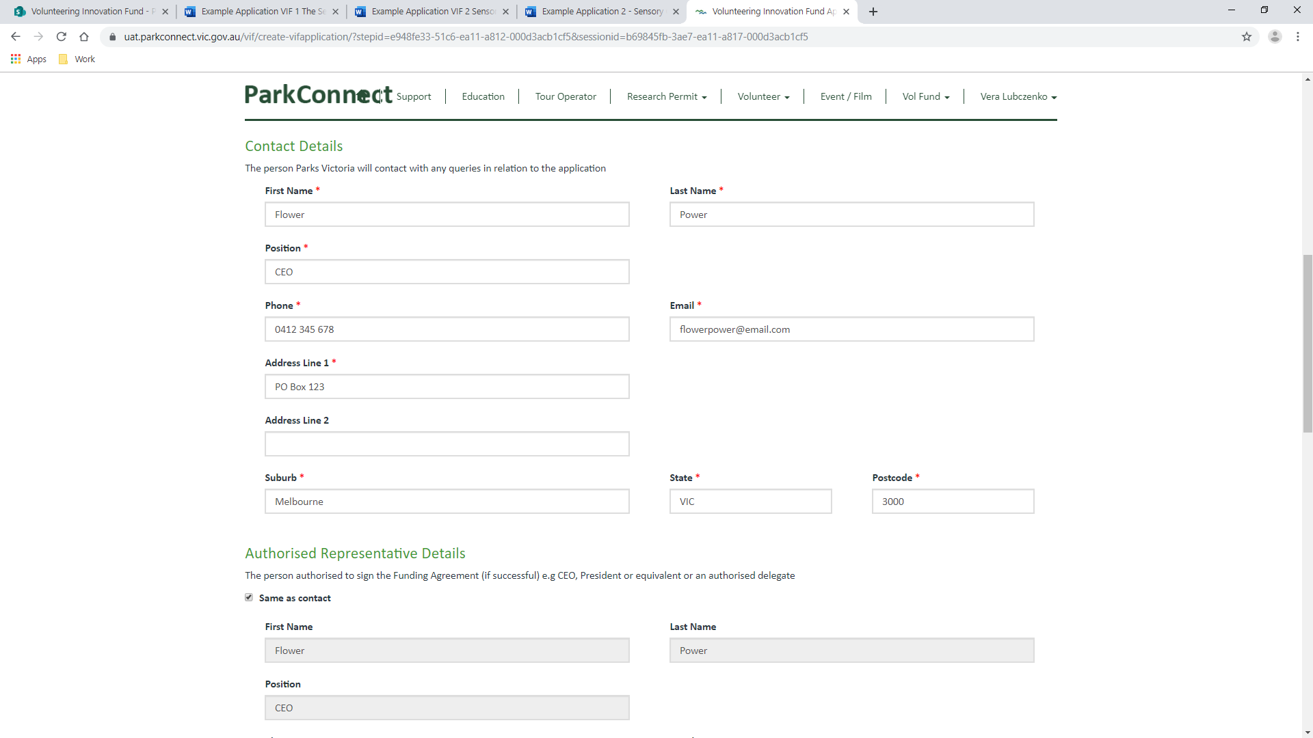

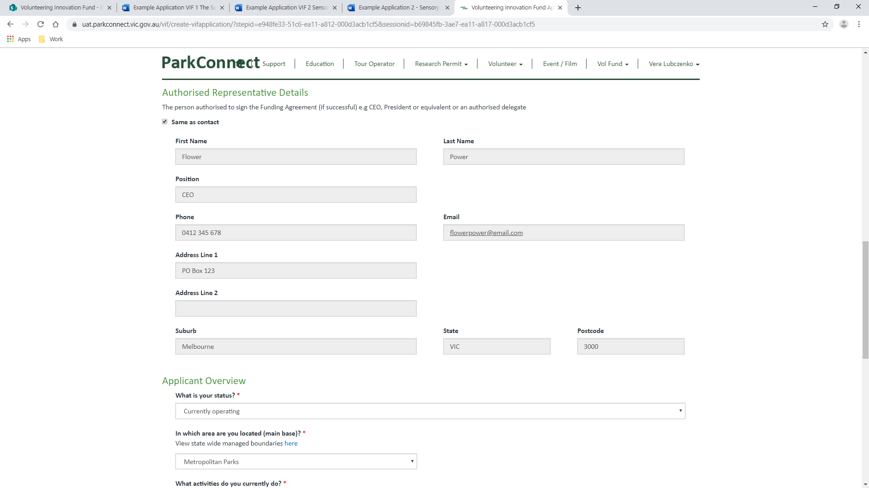

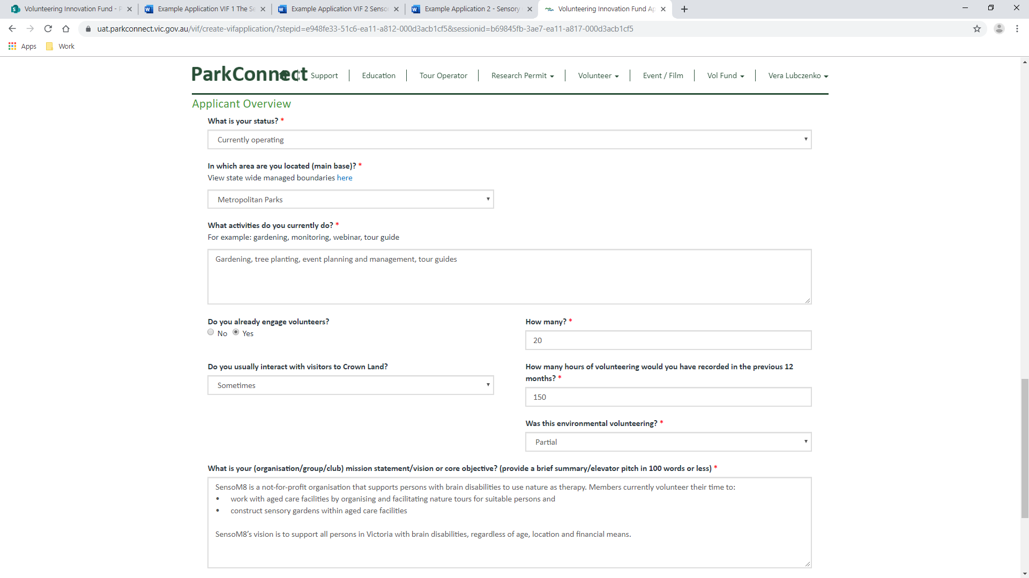

SensoM8 is a not-for-profit organisation that supports persons with brain disabilities to use nature as therapy. Members currently volunteer their time to:

* work with aged care facilities by organising and facilitating nature tours for suitable persons and
* construct sensory gardens within aged care facilities

SensoM8’s vision is to support all persons in Victoria with brain disabilities, regardless of age, location and financial means.

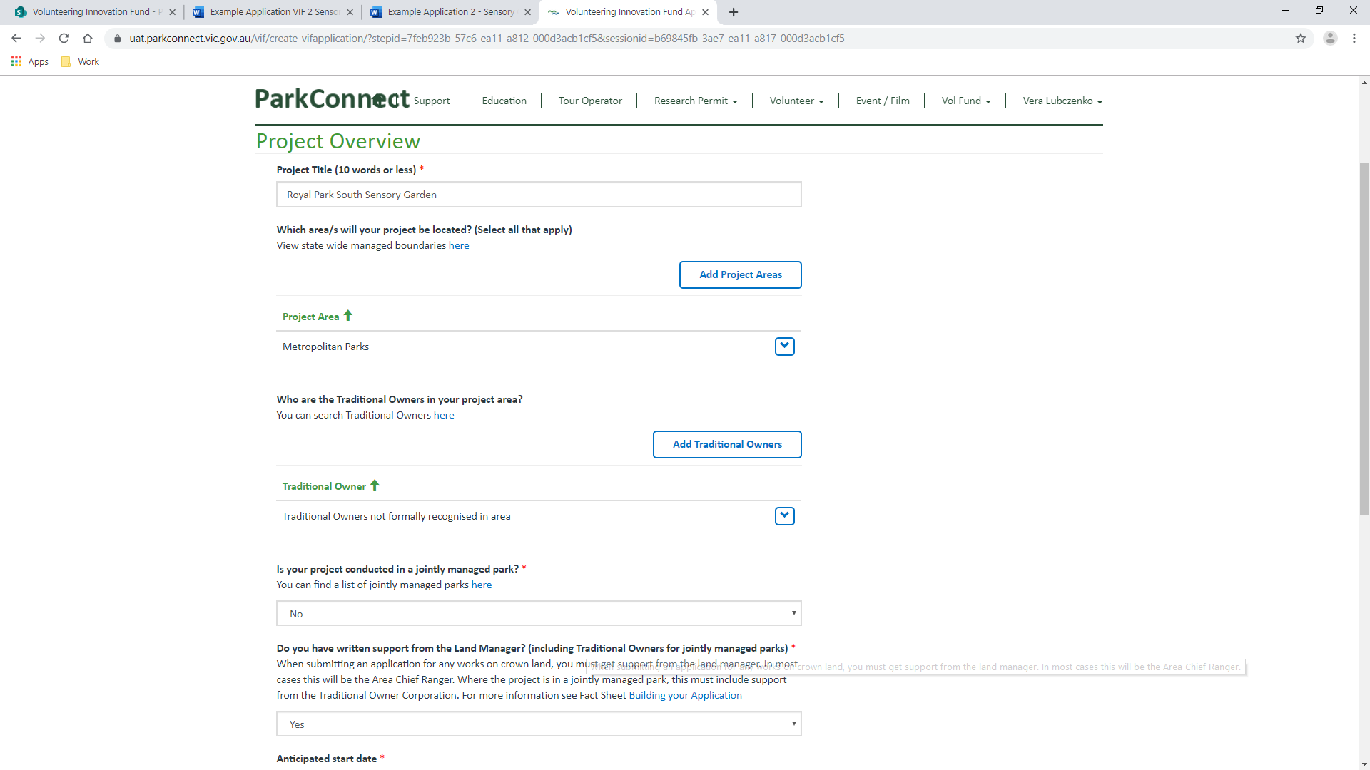

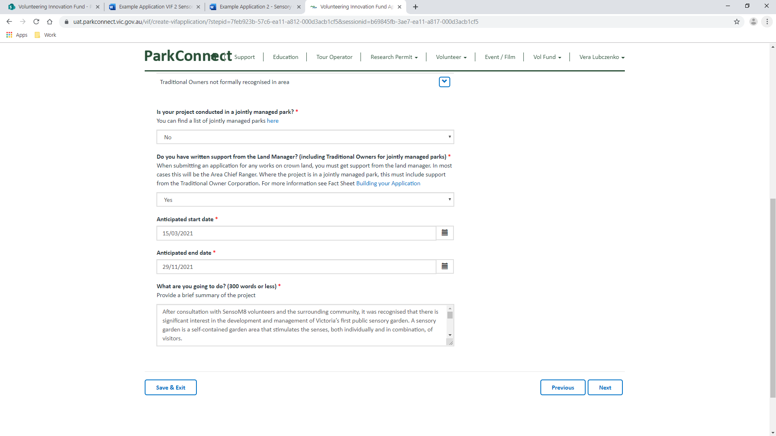



After consultation with SensoM8 volunteers and the surrounding community, it was recognised that there is significant interest in the development and management of Victoria’s first public sensory garden. A sensory garden is a self-contained garden area that stimulates the senses, both individually and in combination, of visitors.

SensoM8 volunteers will:

• Work with Partners to design a sensory garden for persons with brain injuries (including dementia).

• Build the sensory garden, including earthworks to the site, landscaping and planting of flora.

• Construct seating, materials and sculptures.

• Promote the sensory garden.

• Organise and manage garden tours for visitors.

• Organise and manage animal therapy tours (within the sensory garden) in partnership with 123 zoo for visitors.

• Maintain the sensory garden, including beyond the life of this application.

The sensory garden will:

• Be located in Royal Park South, close to Melbourne’s inner city hub and hospitals.

• Use sustainable methodology, including the use of Indigenous flora, eco-friendly materials, landscaping and organic weed control.

• Include indigenous bush food, scented plants, varying colours, engraved seating, play sculptures, water features, varied textures.

The sensory garden will be accessible to the public during Park Hours for unguided visits. SensoM8 volunteers will also offer and arrange guided and animal therapy tours (in partnership with 123 zoo).

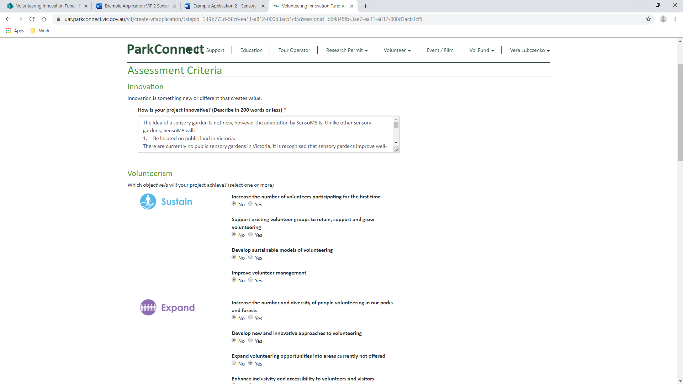

The idea of a sensory garden is not new, however the adaptation by SensoM8 is. Unlike other sensory gardens, SensoM8 will:

1. Be located on public land in Victoria.

There are currently no public sensory gardens in Victoria. It is recognised that sensory gardens improve well‐being and reduce the occurrence of disruptive behaviour. Additionally, incidents of serious falls, sleep and sleep patterns also improve. This garden will benefit locals and visitors to the area.

2. Work with 123 zoo to include animal therapy.

The presence of animals can help reduce the effects of dementia, including anxiety, agitation, irritability, depression, and loneliness. Animals are seen as non-threatening and friendly and can help dementia patients be more interactive, when they are not always able to do so in social settings.

3. Plant and maintain a sustainable garden using indigenous flora cognisant of pre-settlement.

Sustainable gardens conserve water and to maintain water in catchments, provide food and shelter for native mammals, birds and insects and promote stewardship of our natural heritage.



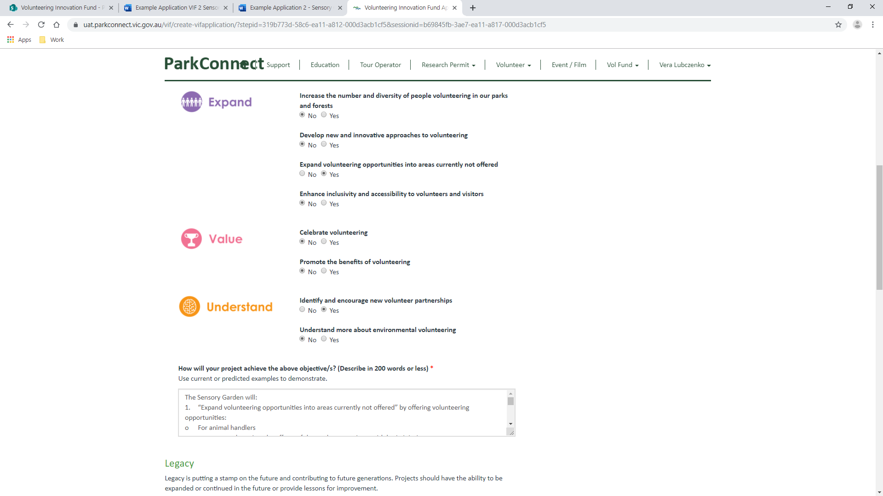

The Sensory Garden will:

1. “Expand volunteering opportunities into areas currently not offered” by offering volunteering opportunities:

o For animal handlers

o to survey and monitor the effects of the garden on patients with brain injuries

o to survey and monitor the effects of the garden on biodiversity

2. “Identify and encourage new volunteer partnerships” by working with:

o 123 zoo to offer animal therapy for the Garden

o ABC Dementia Organisation to promote the garden and program and offer tours for patients with brain injuries

o XYZ Children’s Foundation to promote the garden and program and offer tours for patients with brain injuries

The Sensory Garden will:

1. “Expand volunteering opportunities into areas currently not offered” by offering volunteering opportunities:

o For animal handlers

o to survey and monitor the effects of the garden on patients with brain injuries

o to survey and monitor the effects of the garden on biodiversity

2. “Identify and encourage new volunteer partnerships” by working with:

o 123 zoo to offer animal therapy for the Garden

o ABC Dementia Organisation to promote the garden and program and offer tours for patients with brain injuries

o XYZ Children’s Foundation to promote the garden and program and offer tours for patients with brain injuries

o 789 Hospital to study and report on the effects of sensory gardens on those with brain injuries

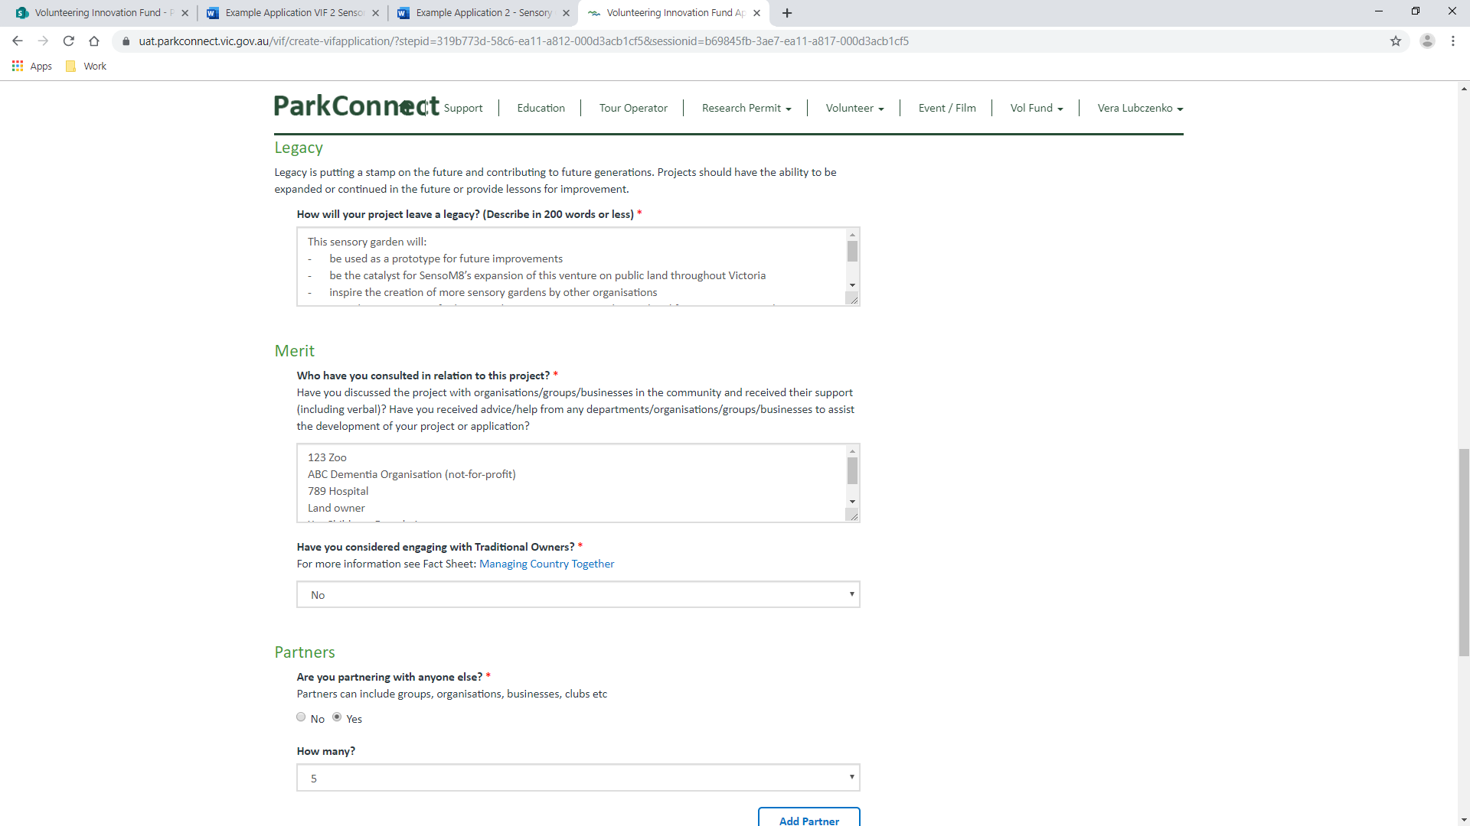

This sensory garden will:

- be used as a prototype for future improvements

- be the catalyst for SensoM8’s expansion of this venture on public land throughout Victoria

- inspire the creation of more sensory gardens by other organisations

- provide opportunities for learnings by ABC Dementia, 789 hospital and future partners in relation to brain injuries

- Provide opportunities for learnings by future partners in relation to sustainable and indigenous gardens and local biodiversity.



123 Zoo

ABC Dementia Organisation (not-for-profit)

789 Hospital

Land owner

Xyz Childrens Foundation

Lovely Nursery



