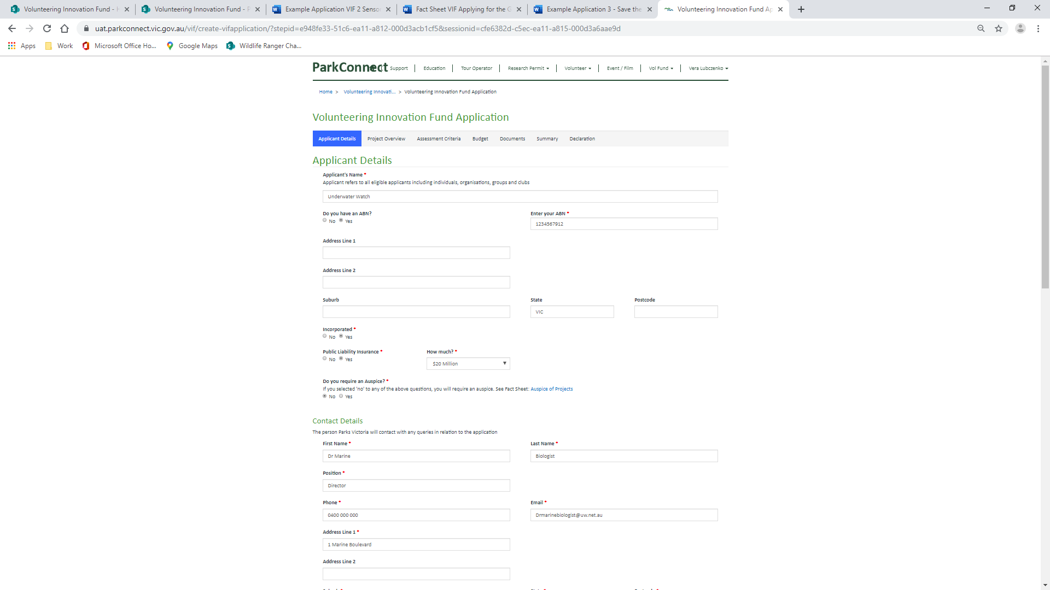

**Underwater forest drop-in volunteers**

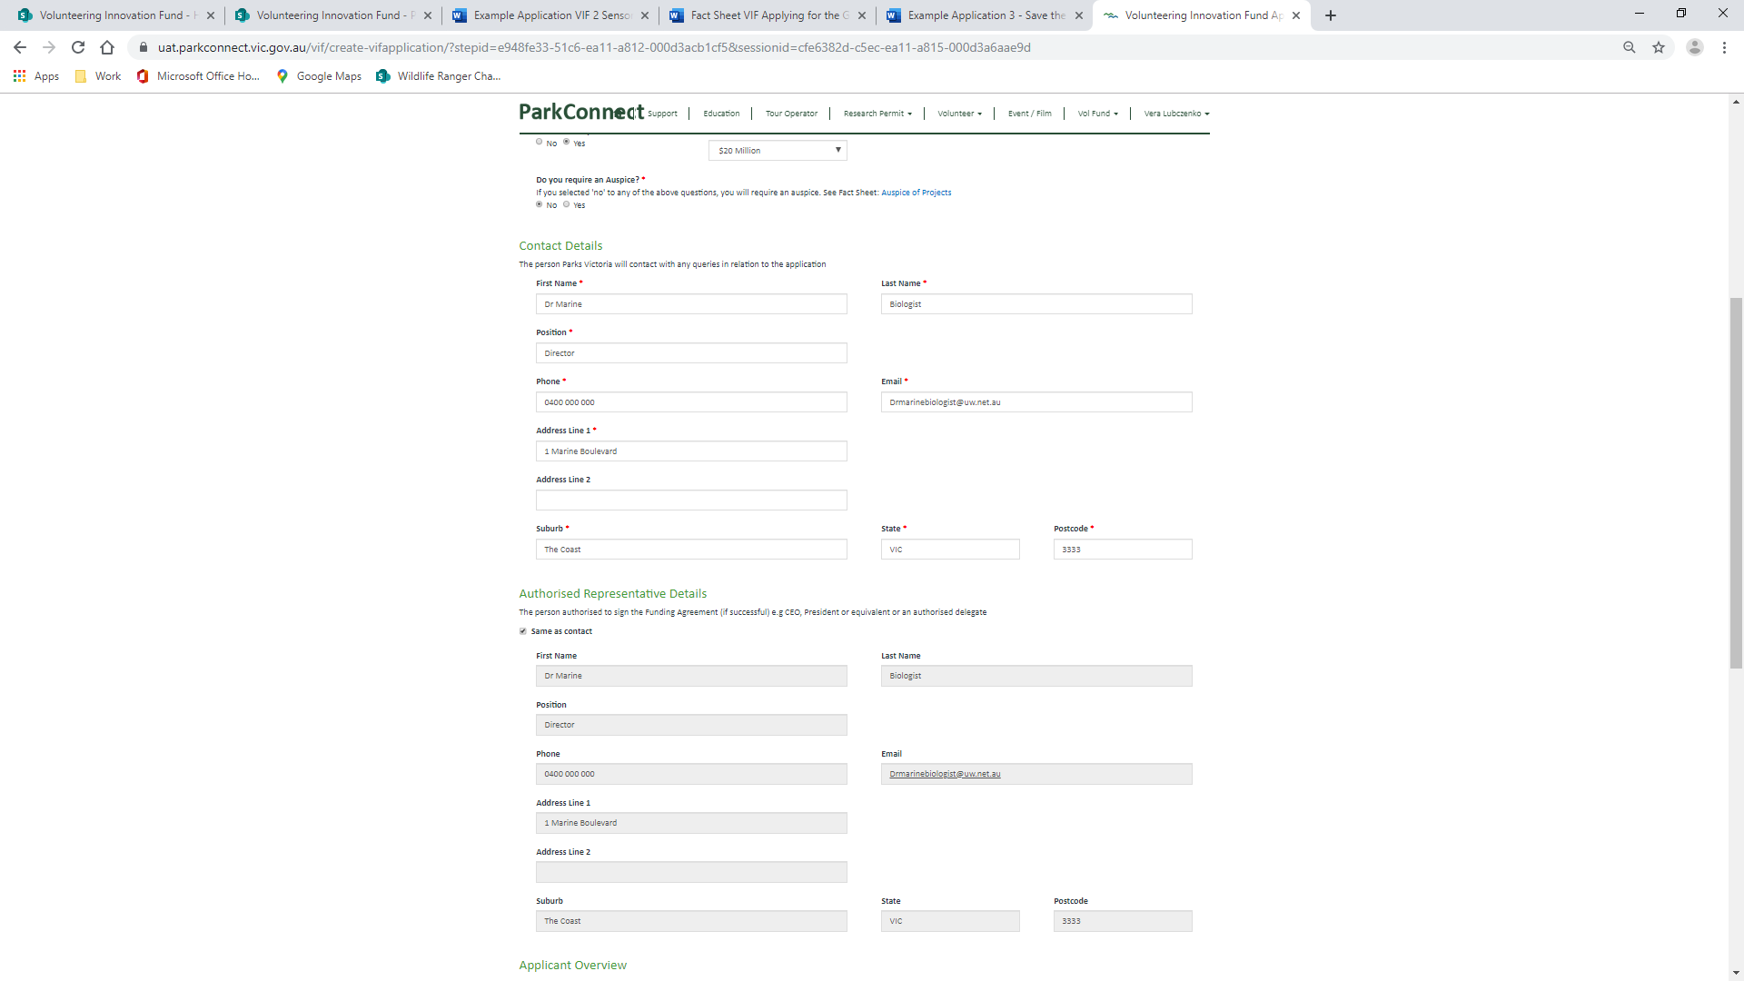

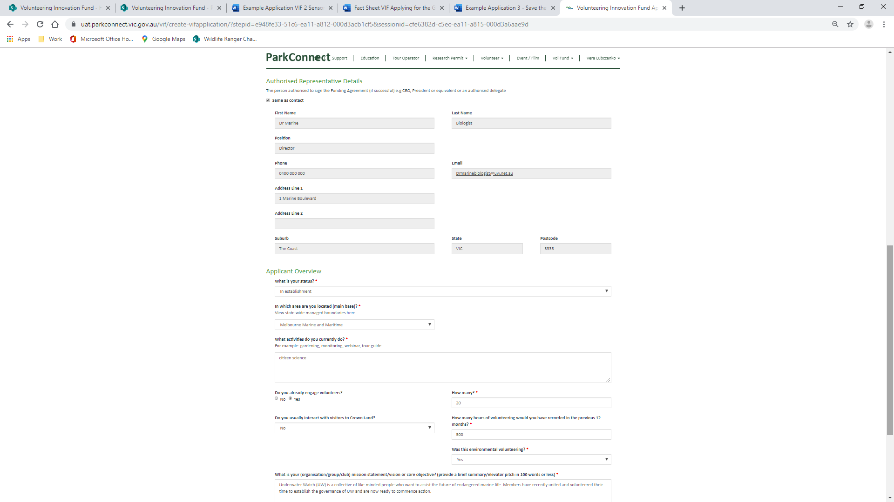

Underwater Watch (UW) is a collective of like-minded people who want to assist the future of marine life. Members have recently united and volunteered their time to establish the governance of UW and are now ready to commence action.

UW will be based in Victoria and work with nationwide partners to track, monitor and report on marine life. Accredited scientists, project managers, software developers, communication and engagement and administration specialists will volunteer their time to identify, establish, undertake and manage citizen science and habitat restoration projects and communicate to the public.

Environmental monitoring, survey and research, habitat restoration, marine park management

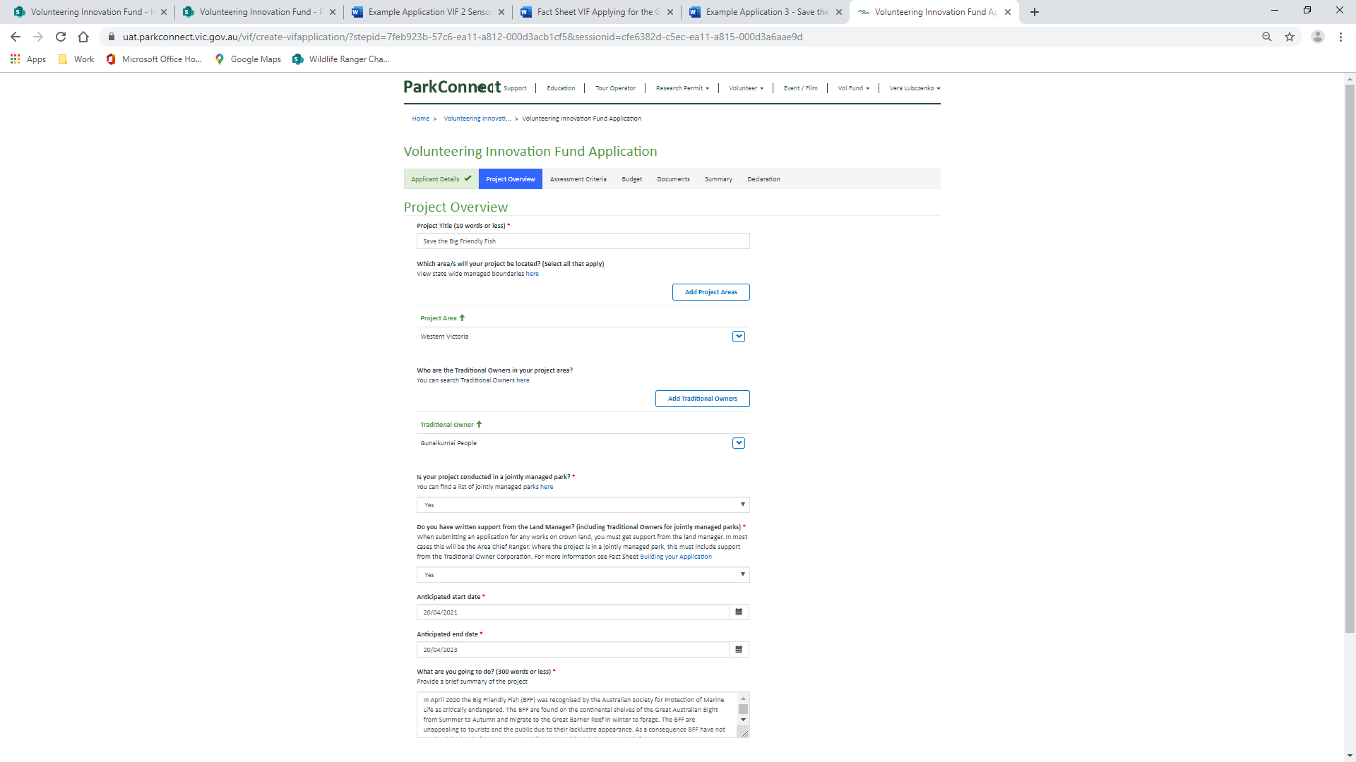

Underwater forest drop-in volunteers

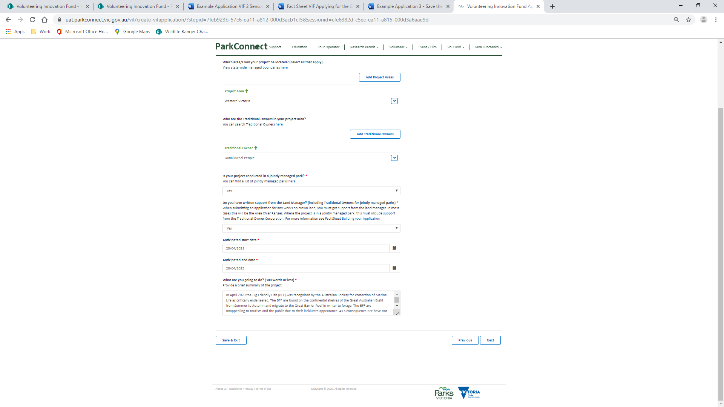

In 2019 Harvard University and National Geographic released articles discussing the effects of “fireproof forests” in combatting global warming. Situated underwater and therefore fireproof, forests of kelp and other macroalgae are being proven as highly efficient at permanently removing carbon dioxide from the atmosphere. UW have decided to launch their organisation to undertake a project establishing, maintaining, tracking and monitoring Kelp Forests. The findings will be reported to the Australian Society for Protection of Marine Life.

The project will be managed by UW and use technology and a mixture of media to communicate and engage with the public. UW software developers will create and launch a free, publicly available app specifically for the project to showcase underwater forests, the work being done and engage with the public. UW will use the app and other communication channels to advertise “drop-in volunteer” days, where the public can “drop-in” and volunteer their time to assist activities. Activities will include propagation and monitoring of kelp forests. Kelp grows along rocky shorelines in eroding conditions. As the habitat erodes, bits of kelp get exported to the deep sea where carbon can be absorbed. This unique lifecycle allows us to work along the easily accessible shore line.

The project will be undertaken over 24 months with periodic data reviews and reports every 3 months. The first stage of the project we are seeking funding for will cover the initial outlay to propagate kelp and marketing campaigns to build traction through the first 6 months.

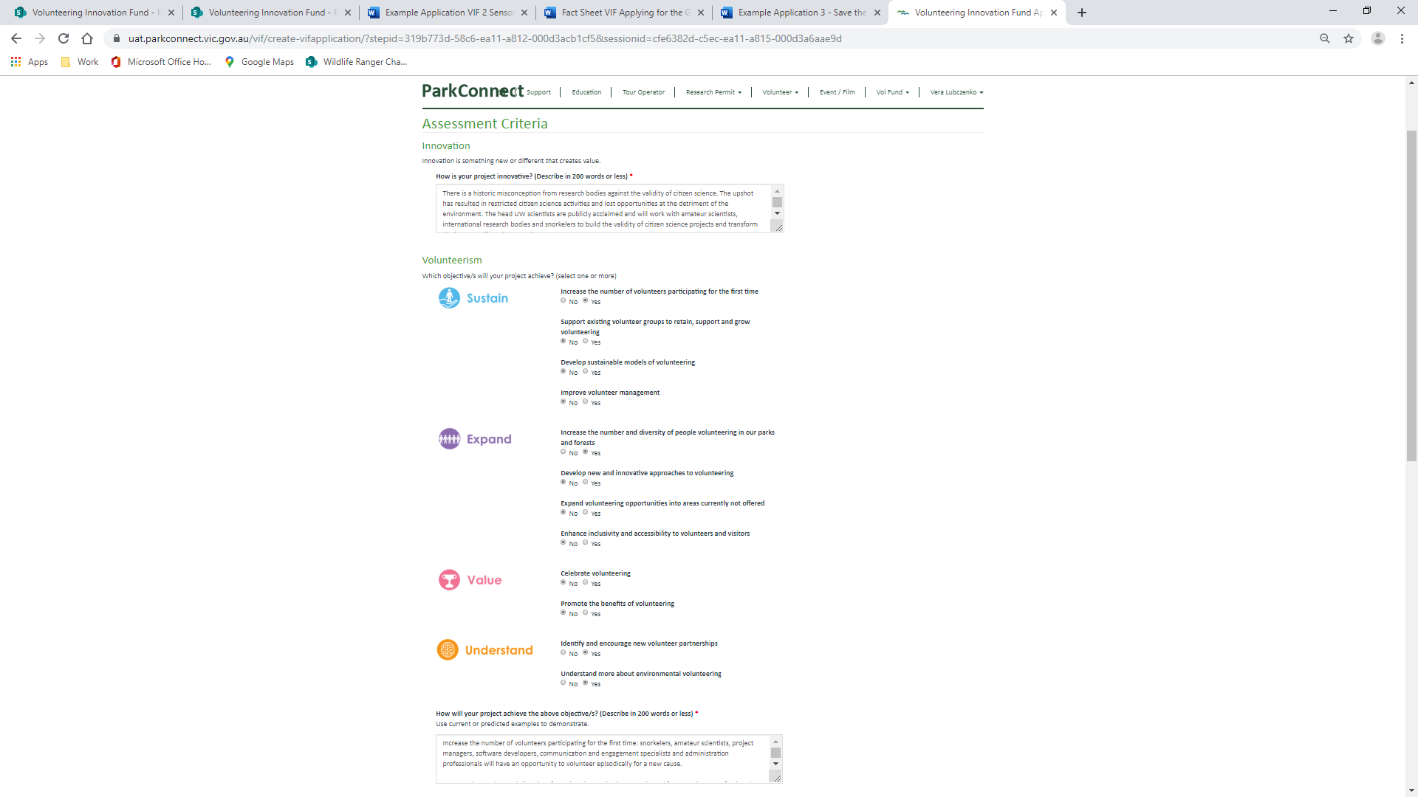

The head UW scientists are publicly acclaimed and will work with amateur scientists, international research bodies and volunteers to contribute to international research on the effects of kelp forests and climate change.

UW will offer multi-weekly drop-in volunteering activities where locals and tourists can turn up on the day and participate in a range of activities. Drop-in volunteering is a new concept and offers hassle-free opportunities.

All data collected will be analysed by UW volunteers and be presented as Movies on the UW app and media channels. Volunteers will feel an additional sense of purpose and contribution to the environment.





Increase the number of volunteers participating for the first time: amateur scientists, project managers, software developers, communication and engagement specialists and administration professionals will have an opportunity to volunteer episodically for a new cause. Drop-in volunteering will offer opportunities to those who have not volunteered previously due to time constraints.

Increase the number and diversity of people volunteering in our parks and forests: Tourists and locals undertaking drop-in volunteering will be from national and international. Science professionals who have previously not volunteered, will commence volunteering activities and encourage others to do so.

Identify and encourage new volunteer partnerships: UW will work with Worldwide Research1 Org and Australian Society for Protection of Marine Life. Neither organisation has previously worked with volunteer organisations.

Understand more about environmental volunteering: UW will collate data and report on feedback from drop-in volunteers including their demographics, motives and experience. This data will be used to improve and adapt UW’s strategic plan and business processes.

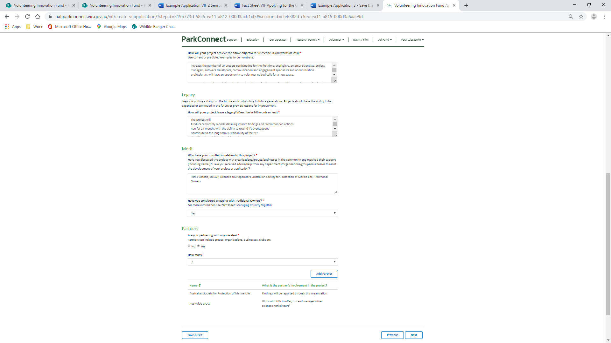

The project will:

Produce 3 monthly reports detailing interim findings and recommended actions

Run for 24 months with the ability to extend if advantageous

Contribute to the counter effects of climate change

Identify and establish other project locations

Collate feedback from volunteers to continually adapt UW and build towards a long-standing and valued volunteer organisation.



Parks Victoria, DELWP, Worldwide Research1 Org, Australian Society for Protection of Marine Life, Traditional Owners



