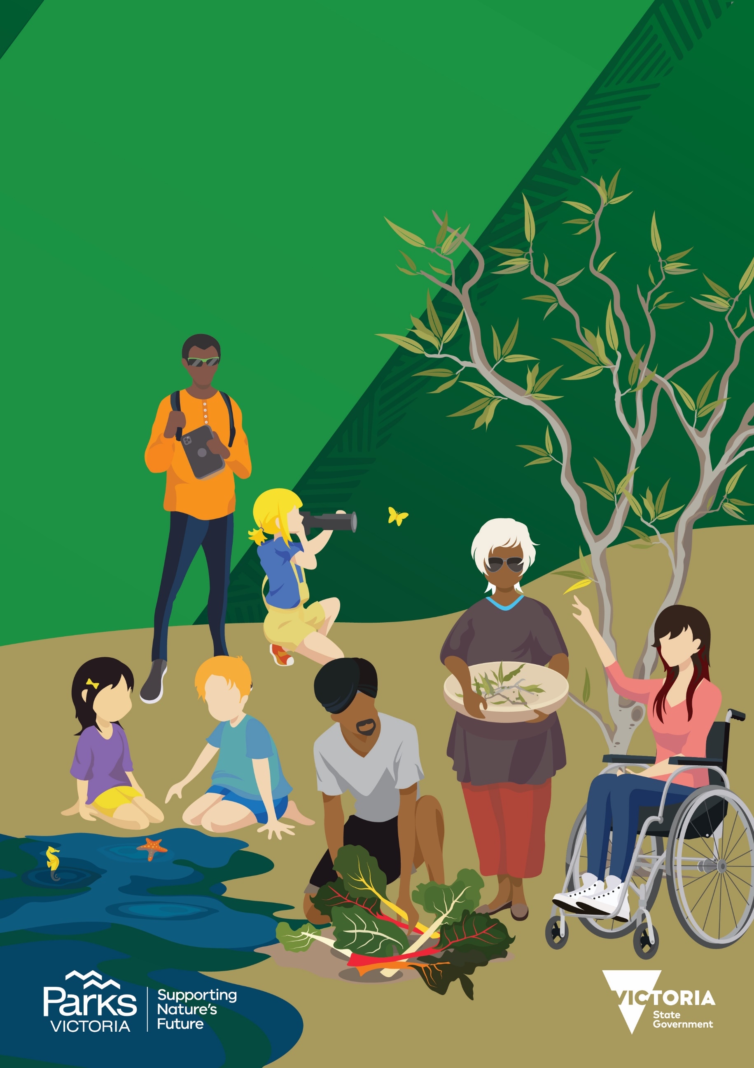
VOLUNTEERING

INNOVATION FUND

Funding Guidelines V4.1

Contents
What is the Volunteering Innovation Fund? 3
Who can apply? 4
What can be applied for? 5
How do I apply? 7
How will applications be assessed? 8
How are outcomes announced? 9
Handy links 11
What is the process flow? 12
What are the Terms and Conditions? 14
Acknowledgements 15

What is the Volunteering Innovation Fund?
The Volunteering Innovation Fund is a key new initiative under the Victoria’s Great Outdoors Program, which seeks to get more Victorians, from all walks of life outdoors enjoying nature. The Volunteering Innovation Fund supports Victoria’s Volunteering for Nature - Environmental Volunteering Plan and Protecting Victoria’s Environment - Biodiversity 2037 and will provide new opportunities to encourage volunteering in and for nature.
The Volunteering Innovation Fund will award $2 million in competitive funding over three years. There will be four rounds, with the final round closing in 2022. Parks Victoria invited the public to vote on Round 2, where Victorians could have a say in the future of volunteering.
Successful applications will be those that support, expand and diversify environmental volunteering for all Victorians to get involved. They will be new and different ideas that create change, inspire volunteering and leave a legacy.
SEPT 2020
Volunteering Innovation Fund launches
Public voting round
Biodiversity ROUND
Up to $50,000
Spring 2022
ROUND 2
Up to $50,000
Autumn 2021 2021

2022
Volunteering Innovation Fund closes
ROUND 3
Up to $30,000
Spring 2021
ROUND 1
Up to $20,000
Spring 2020

Round 4 details:
Round 4 Opens | 9.00am Friday 19 August 2022
Round 4 Closes | 5.00pm Monday 17 October 2022
Funding available | up to $50,000 (exclusive of GST)
Location | Crown land (Victoria)
Eligible projects | Innovative volunteering projects that benefit Victoria’s environment (including cultural and heritage values) and environmental volunteering.
Eligible applicants | Individuals and organisations interested in volunteering
Auspice/Sponsor | Yes
Outcomes announced | January 2023
Projects completed by | 12 months

Who can apply?
The Volunteering Innovation Fund is open to individuals and organisations interested in volunteering. To be eligible, you must adhere to the following eligibility requirements
Eligible: | Ineligible:
☐ Bank Account  ☐ ABN  ☐ Incorporated (or body corporate) or  ☐ Applicants (including individuals) with  eligible auspice | ☐ Local Governments  ☐ State and Federal government departments  ☐ Applicants who have an open Volunteering Innovation Fund project  ☐ Applicants who have overdue funding agreements and/or reporting requirements with Parks Victoria

Who can auspice an application?
The following organisations can auspice a project (but are not eligible to apply in their own right):
☐ Volunteer Authorities
☐ Industry Bodies
☐ State Government statutory bodies/authorities (excluding Parks Victoria and DELWP)
☐ Local government

Auspicing Organisations must:
☐ be either incorporated, a state/local government body or body corporate
☐ hold personal accident insurance and a minimum of $10 million public liability insurance
☐ sign the funding agreement
☐ receive the funding payment to ensure the project can proceed
☐ be accountable for the delivery and reporting of the project

Can we partner with another organisation?
Yes, this is highly regarded. Applicants can partner on projects with other organisations (including those that do not meet the eligibility criteria). Include the details of your partner in the application form.

Can we engage contractors to undertake activities?
Contractors will be permitted for low risk activities only. Applicants will need to enter into an additional agreement between all parties and the contractor if your application is successful. Include the activity details which require contractor engagement in your application form.

Can we re-apply to the fund while waiting for the outcomes to be announced?
No. Outcomes will be announced before the preceding round closes. If you are notified of an unsuccessful application, you are then able to re-apply. Upon receipt of unsuccessful notification, you can request feedback and consider addressing in any future applications.

What can be applied for?
Funding is available for a broad range of innovative volunteering projects on Victorian Crown land that benefit heritage and cultural values and improve the natural environment. Projects should:
- invite more Victorians to volunteer in and for the environment
- have the ability to leave a legacy (can be continued/expanded/extended/re-invigorated in the future); and
- be a new method, idea, item, event or service.

Projects must address one or more of the following ‘Victorians Volunteering for Nature, Environmental Volunteering Plan’ Key Focus Areas:
- Increase the number of volunteers participating for the first time
- Support existing volunteer groups to retain, support and grow volunteering
- Develop sustainable models of volunteering
- Improve volunteer management
- Increase the number and diversity of people volunteering in our parks
and forests
- Develop new and innovative approaches to volunteering
- Expand volunteering opportunities into areas currently not offered
- Enhance inclusivity and accessibility to volunteers and visitors
- Celebrate volunteering
- Promote the benefits of volunteering
- Identify and encourage new volunteer partnerships
- Understand more about environmental volunteering

How much can I apply for?
In Round 4 funding up to $50,000 (exclusive of GST) is available per project.

Can I apply for funding for the whole project?
Applications to fund the project in part and in full will be accepted. While financial contributions are not required, it is looked upon favourably. Financial contributions can be from the applicant, a partner organisation or in-kind volunteer hours.

What is the Biodiversity Round?
Round 4 is a special round targeted to protect Victoria’s environment. Projects that address Protecting Victoria’s Environment -Biodiversity 2037 will be prioritised. See the assessment criteria for more information.

How do I calculate the cost of our volunteer contribution?
When calculating the in-kind contribution for your application budget, volunteer time should be costed at $42 per hour. Multiply the number of volunteers by the hours they will spend on your project, then multiply by $42. Example: 35 volunteers x 10 hours each x $42 = $14,700 in volunteer time contribution.

Do projects have to benefit a specific location?
Projects must benefit and/or be conducted on Crown land within Victoria consent under relevant legislation.

What won’t be funded?
☐ Projects already underway  ☐ Projects conducted on private land/reserves/estates  ☐ Projects that will cause harm | ☐ Projects conducted on council land/reserves/estates  ☐ Capital Works projects  ☐ Projects that require a Cultural heritage Management Plan

Can I submit multiple applications?
Applicants can submit multiple applications to multiple rounds, however can only have 1 x open Volunteering Innovation Fund application with Parks Victoria at any one time. In the instance of multiple applications being submitted in the same round and recommended for funding, the application with the highest scoring/votes will be awarded. The remaining application/s will then be automatically withdrawn. If successful, applicants are only able to re-apply to the Volunteering Innovation Fund once their current project is acquitted and closed.
Applicants can submit and be awarded funding while partnering with other lead applicants. Applicants cannot be the Lead Applicant of two open projects.

When are outcomes announced?
Outcomes will be announced approximately 4 months after the closing date.

Will I need to sign an Agreement?
Successful applicants will be required to enter into an agreement with Parks Victoria, outlining the requirements of both the recipient (you) and grantee (Parks Victoria).
The short Victorian Common Funding Agreement will be used (https://www.vic.gov.au/victorian-common-funding-agreement). Parks Victoria may add additional conditions, dependent on the scope of the approved project.

When do the projects have to be completed by?
Successful applicants are required to complete their projects and submit acquittals within 12 months from the deposit of funding from Parks Victoria.

Successful applications
You can find a list of successful applications and project overviews on Park Web

www.parks.vic.gov.au/volunteering-innovation-fund

Strategic Alignment
The Volunteering Innovation Fund aligns with two important Strategies;

Protecting Victoria’s Environment - Biodiversity 2037
Protecting Victoria’s Environment – Biodiversity 2037 is the Victorian State Government’s policy response to addressing the decline in biodiversity. The Biodiversity Plan presents a long-term vision for Victoria’s biodiversity supported by two goals:
- Victorians Value Nature, and
- Victoria’s natural environment is healthy.
Specific targets have been developed to deliver on these goals, and 20 priorities have been identified to guide actions. Conservation actions delivered through the plan will be more strategic, deliver better value for money and will be underpinned by the best available science to ensure efforts deliver the most benefit for the most species

Victorians Volunteering for Nature - Environmental Volunteering Plan
Supporting, improving and expanding the environmental volunteering sector in Victoria will contribute directly to the vision and goals of Biodiversity 2037. Of particular relevance is the target of five million Victorians acting to protect the natural environment by 2037.
The Volunteering Innovation Fund aims to inspire ideas and fuel innovation by funding community-led projects that consider new ways of volunteering in and for the environment to help reach this target.

How do I apply?
Applications need to be submitted on-line through Park Connect. If you haven’t already, you will need to register an account. Use the below link to register and start your applications:
www.parkconnect.vic.gov.au/vif
You will receive an application number after you apply online. Please quote this number in all communications with Parks Victoria relating to your application. All applications need to be submitted by the due date. Late and incomplete applications will not be considered.
If you require assistance, please call the Volunteering Innovation Fund helpline on:
1300 375 323 or email VolunteeringFund@parks.vic.gov.au

What needs to be included in my application?
Below is a table of the application requirements.
Requirements
Application form | - Completed in full  - Filled out correctly  - Submitted on-line before the cut-off date and time
ABN | ☐ Copy of ABN (https://abr.business.gov.au/)
Quotes | Item cost:  - <$2,000 (Incl. GST)  - 1 written quote  - $2,001 > $50,000 (Incl. GST)  - 2 written quotes
Approvals/written support | ☐ Primary Land manager/Area Chief Ranger (i.e. Parks Victoria, DELWP, Traditional Owner)  ☐ Traditional Owner Corporation (if within jointly managed land https://www.parks.vic.gov.au/managing-country-together)
Supporting Documentation | - Under 3mb in file size  - Maximum of 7 files  - File formats:  - MS Word  - MS Excel  - PDF  - JPEG

How will applications be assessed?
All applications will be assessed by a panel of independent assessors on 4 criteria. Each assessor will score applications with a score between 1-7 for each criterion. Scores are then calculated, producing a ranking list of all applications. The top scoring applications will be awarded successful.
Biodiversity 2037 Targets
Does the project address the following themes?
- Threatened species
- Threatened communities
- Biodiversity threats
- Predation (predator and herbivore)

Does the project include the following activities?
- Habitat restoration and/or revegetation
- Weed control
- Scientific research
- Predation control
Projects that address Protecting Victoria’s Environment -Biodiversity 2037 targets will be preferenced.

The four criteria are below:
Weight = 40%
Description
How innovative is the project?
Other elements
- How well does the project address the following definition: Something new or different that creates value.
- Does the project invoke a change?
- Does the project develop new and different approaches to volunteering?

INNOVATION
Weight = 30%
VOLUNTEERISM

Description
Does the project address the ‘Victorians Volunteering for Nature, Environmental Volunteering Plan’?

Other elements
- Will the project increase the number of:
- Volunteers participating for the first time
- Diversity of people volunteering
- Volunteering opportunities currently
not offered
- Volunteer partnerships
- Will the project improve:
- The ability to retain, support and grow volunteering
- Volunteer management
- Inclusivity and accessibility to volunteers
and visitors
- Understanding of environmental volunteering
- Will the project celebrate and promote the benefits
of volunteering?

MERIT
Weight = 20%

Description
What are the overarching benefits
of the project?
Other elements
- What are the benefits to the environment?
- What are the intangible benefits?
- What is the extent of community support for the
project (including Traditional Owners)?
- Is the project culturally sensitive and appropriate
- Are the costs appropriate for the project?
- Have sources of funding been clearly identified?
- Is the volunteer group contributing towards the project?
- Can funding be better source elsewhere?

Description
Will the project leave a legacy?
Other elements
- Can the project be expanded?
- Can the project be continued in the future?
- Does the project develop sustainable models
of volunteering?
- Can the project provide lessons for the future?
LEGACY
Weight = 10%

How are outcomes announced?
The outcomes of each application will be announced by Round. Successful applications will be announced publicly. Each applicant will then receive an email from ParkConnect advising of the Outcome. This can take up to 1 week. Outcomes will take the following timeframes:

ROUND 4
Outcome timeframe: 4 months

Pre-round advertising
2 weeks
Open
6 weeks
Application collation
2 weeks
Assessment
4 weeks
Approvals
6 weeks

Acquittals
Project completion and acquittals submitted 12 months from date of funding payment transferred by Parks Victoria

I’m successful, where to next?
Successful applicants will receive a Funding Pack consisting of the following:
- Success letter (with instructions)
- Funding Agreement
- Project Plan
- Request for Variation form
- Acquittal form
The Funding Agreement and all required documentation must be signed and submitted by the notified due date.
Projects must be managed by the applicants and completed, and acquittals submitted by the due date.

What other documentation will I be required to provide if my application is successful?
All required documentation will be specified in the Funding Pack. Successful recipients will be required to submit the following applicable documents:
Mandatory: | If applicable:
☐ Signed Funding Agreement and attachments  ☐ Certificate of Currency  ☐ Job Safety Plan (attach to ParkConnect profile)  ☐ Working with Children Checks  (attach to ParkConnect profile) | ☐ Gantt chart  ☐ Cultural Heritage Assessment  ☐ Cultural Heritage Permissions  ☐ Traditional owner support  ☐ Permits/access agreements  ☐ Accreditations/licences/competencies  (attach to ParkConnect profile)  ☐ Agreement to engage contractors

Can I change my project after submitting the application?
If it is determined that you cannot complete the project (as applied for) before being notified of outcomes, you must withdraw your application.
If the project has been notified of success and is underway and it is later determined that the project scope needs to change, you can submit a Request for Variation. Requests can be made for the following:
- Project scope
- Project timelines

How do I request changes to the project?
A Request for Variation can be made by submitting the form in Park Connect. The request will be reviewed by Parks Victoria and a response will be returned within 3 weeks. Do not make any changes to your project until you receive a response to your request.

How do I close my project?
Upon completion of your project, submit an Acquittal Form through Park Connect with all required supporting documentation. Acquittals can only be submitted once your project is complete. Parks Victoria will review your acquittal and respond within 4 weeks’.

What supporting documentation is required to acquit?
When submitting an acquittal, recipients must also attach the following applicable documents:
Mandatory: | Optional:
☐ Invoices  ☐ Proof of payments/receipts  ☐ Copy of all publicity  ☐ Photos | ☐ Feedback  ☐ Reports  ☐ Other

Should I promote my project?
Yes! We want you to spread the word about the great work you are doing. You can involve the public throughout and at the completion of your project. If successful, promotional guidelines will form part of the funding agreement.

What happens if my application is unsuccessful?
Unsuccessful applicants will have the ability to request feedback within 14 days of being notified. Feedback can assist complete future applications. You can also re-apply to future rounds.

Lodging Grievances
If you would like to lodge any grievances regarding the outcome of your application, please submit a signed letter to:
Email: | VolunteeringFund@parks.vic.gov.au

Handy links
Park Web: www.parks.vic.gov.au/volunteering-innovation-fund
Park Connect: www.parkconnect.vic.gov.au/vif

What is the process flow?
The below diagram demonstrate the flow of applications from submission to completion.
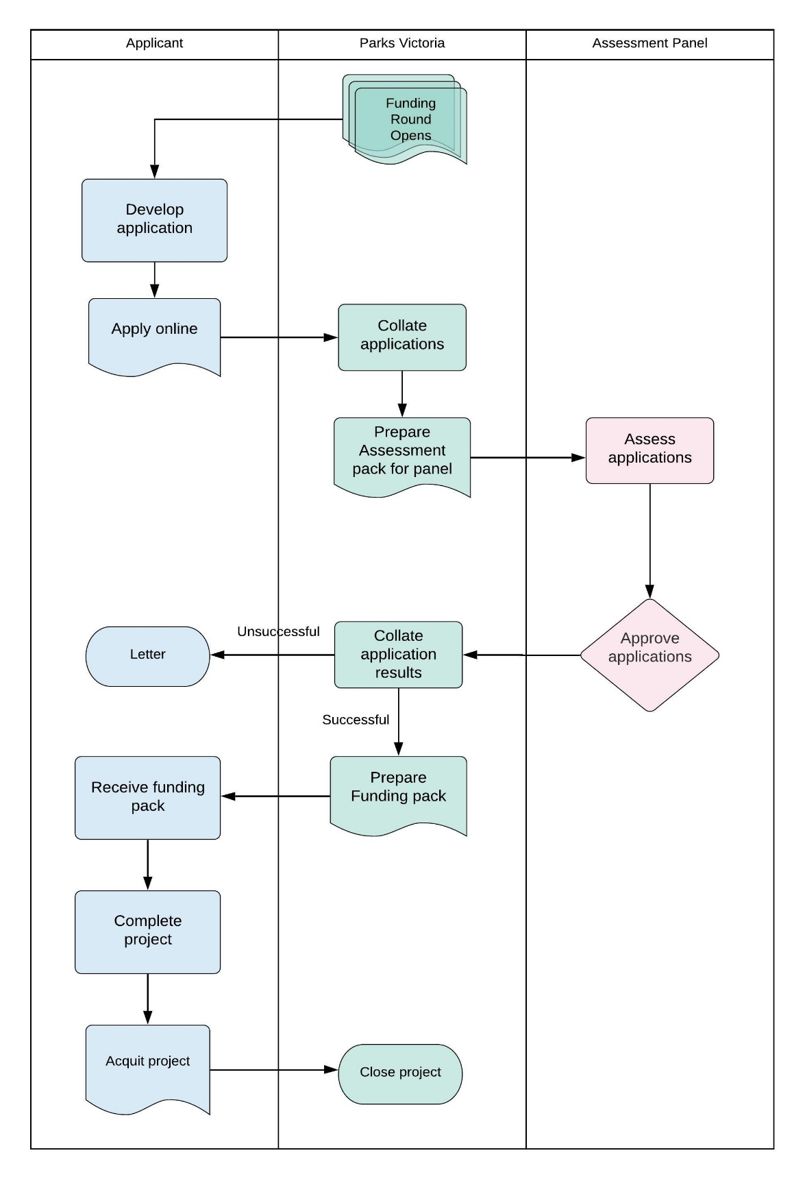

What are the Terms and Conditions?
For successful applications, the total project cost must be supported by written quotation(s) and details of in-kind contributions prior to payment of the funding.
The following conditions will apply to successful applicants:
- Enter into a short form Funding Agreement. https://www.vic.gov.au/victorian-common-funding-agreement
- Successfully funded projects will be offered funding as GST inclusive or exclusive amounts based on the registration of the applicant’s/auspicor’s ABN.
- On and from the Start Date effect and maintain public liability insurance cover for at least $10,000,000 for any one occurrence for the duration of this Agreement, and for insurance policies that are on a ‘claims made’ basis for no less than six years after the completion of the Activity.
- Work on Crown land requires owner consent. Support can be given based on discussions with your local Parks Victoria/Department of Environment, Land, Water and Planning Officer. Recipients are responsible for obtaining all necessary permits, approvals and consents prior to the commencement of any works.
- Projects must commence within two (2) months of entering into the Funding Agreement with Parks Victoria. Projects that have not commenced within this timeframe must contact the Fund team to explain the delays and negotiate an appropriate commencement date. Recipients that fail to provide this advice may risk voiding the Funding Agreement and may have to return any funds provided.
- Project activities must be entered in to ParkConnect and all volunteers need to register their participation
- Projects must be completed, and acquittals submitted within 12 months from deposit of funding from Parks Victoria.
- Funds must be spent on the project as described in the application and any unspent funds must be returned to Parks Victoria, as per the Funding Agreement.
- Additional project costs must be funded by the applicant.
- Any variation to the approved project must be submitted to Parks Victoria for approval prior to implementation.
- Acknowledgement of the Victorian Government’s support: Promotional guidelines will form part of the funding agreement.
- Successful applicants must liaise with the Fund team to coordinate any public events or announcements related to the project.
- Contribute information on activity outcomes for use in program evaluation reviews or the department’s marketing materials.
- Submit reports detailing the progress and outcomes of the funding as per the Funding Agreement.
- Complete and provide a project acquittal and any other completion reports required.
- Project must adhere to all applicable Parks Victoria volunteering management policies and procedures, including the use of ParkConnect.

Acknowledgements
By applying, the applicant acknowledges that:
- Volunteering Innovation Fund Funding Guidelines v2.0 have been read and understood.
- All information provided within your application is correct - providing any false or misleading information may result in the rejection of the application.
- PV may seek to confirm any information contained in your application and may request additional information. Failure to provide the information may mean that the application is unable to be assessed and result in the rejection of the application.
- If successful, details of the funding project will be made public on the Parks Victoria or other vic.gov.au website.
- The applicant and lessee of the property agree to allow Parks Victoria to use or publish any photographs supplied for the purposes of promotion on the Parks Victoria website, intranet and social media accounts, or in any printed material or media.
- They recognise Parks Victoria is collecting your personal information (such as your name and contact details) and supporting material in order to assess your eligibility for funding and contact you about your application. Your information will be held and managed in accordance with the Privacy and Data Protection Act 2014 and the Public Records Act 1973.
- Personal information about you or a third party in your application will be collected by Parks Victoria for the purpose of funding administration. This information may be provided to other Victorian government bodies for the purposes of assessing your application. If you intend to include personal information about third parties in your application, please ensure they are aware of the contents of this privacy statement.
- Any personal information about your or a third party in your correspondence will be collected, held, managed, used, disclosed or transferred in accordance with the provisions of the Privacy and Data Protection Act 2014 and other applicable laws
- Parks Victoria is committed to protecting the privacy of personal information. You can find the Parks Victoria Privacy Policy online at www.parks.vic.gov.au/privacy Requests for access to information about you held by Parks Victoria should be emailed to info@parks.vic.gov.au, or sent to Parks Victoria, Level 10, 535 Bourke Street, Melbourne VIC 3000 or made by phone to 13 19 63. Information and uploaded images and documentation in this application is stored on departmental systems.

