When do I request a Variation?
If it is determined that you cannot complete the project as per the executed Funding Agreement, you can request a variation through ParkConnect.

Parks Victoria will review the request and advise you of the outcome. This can take up to 3 weeks. Please do not commence any works relating to the variation request until Parks Victoria has reviewed and advised of the outcome. If we require any information in the interim, we will be in contact with the nominated Contact Person.

What can I request a variation for?
Successful applicants can request the following variations to their project:
- an extension to the due date
- change of scope (including activities, locations, items)
Parks Victoria will not accept variations to increase the funding amount. Any additional expenses must be funded by the applicant.

How many variations can I request?
There is no limit on the number of variation requests per successful project. Variation Requests may not be approved, so it is best to comprehensively plan your project when applying and completing your project plan.

Further Information
Fact Sheet VIF Successful Applications
Fact Sheet VIF Publicising Successful Projects
www.parkconnect.vic.gov.au

Legal accountability
Parks Victoria is legally responsible to properly account for public money. This responsibility includes accounting for any funds provided to groups through Parks Victoria, under any funding program. By accepting funds from Parks Victoria, the group also becomes legally accountable to ensure that the public money is properly spent.

Contact us
If you have any queries, or require more information, please contact Parks Victoria via: email: VolunteeringFund@parks.vic.gov.au or phone: 1300 375 323

Access the Volunteering Innovation Fund
To access the Volunteering Innovation Fund click on the below icons on the ParkConnect home page:
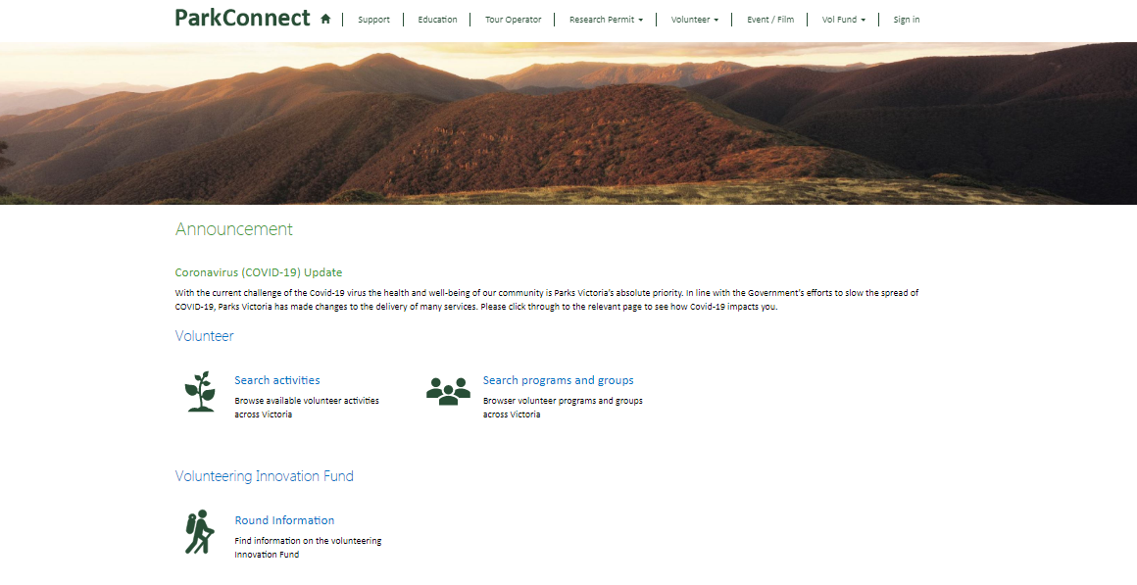
You will be taken to the Volunteering Innovation Fund (VIF) landing page. You can access the VIF dashboard, your applications and project plans through the blue outlined button, or through the top navigation bar.
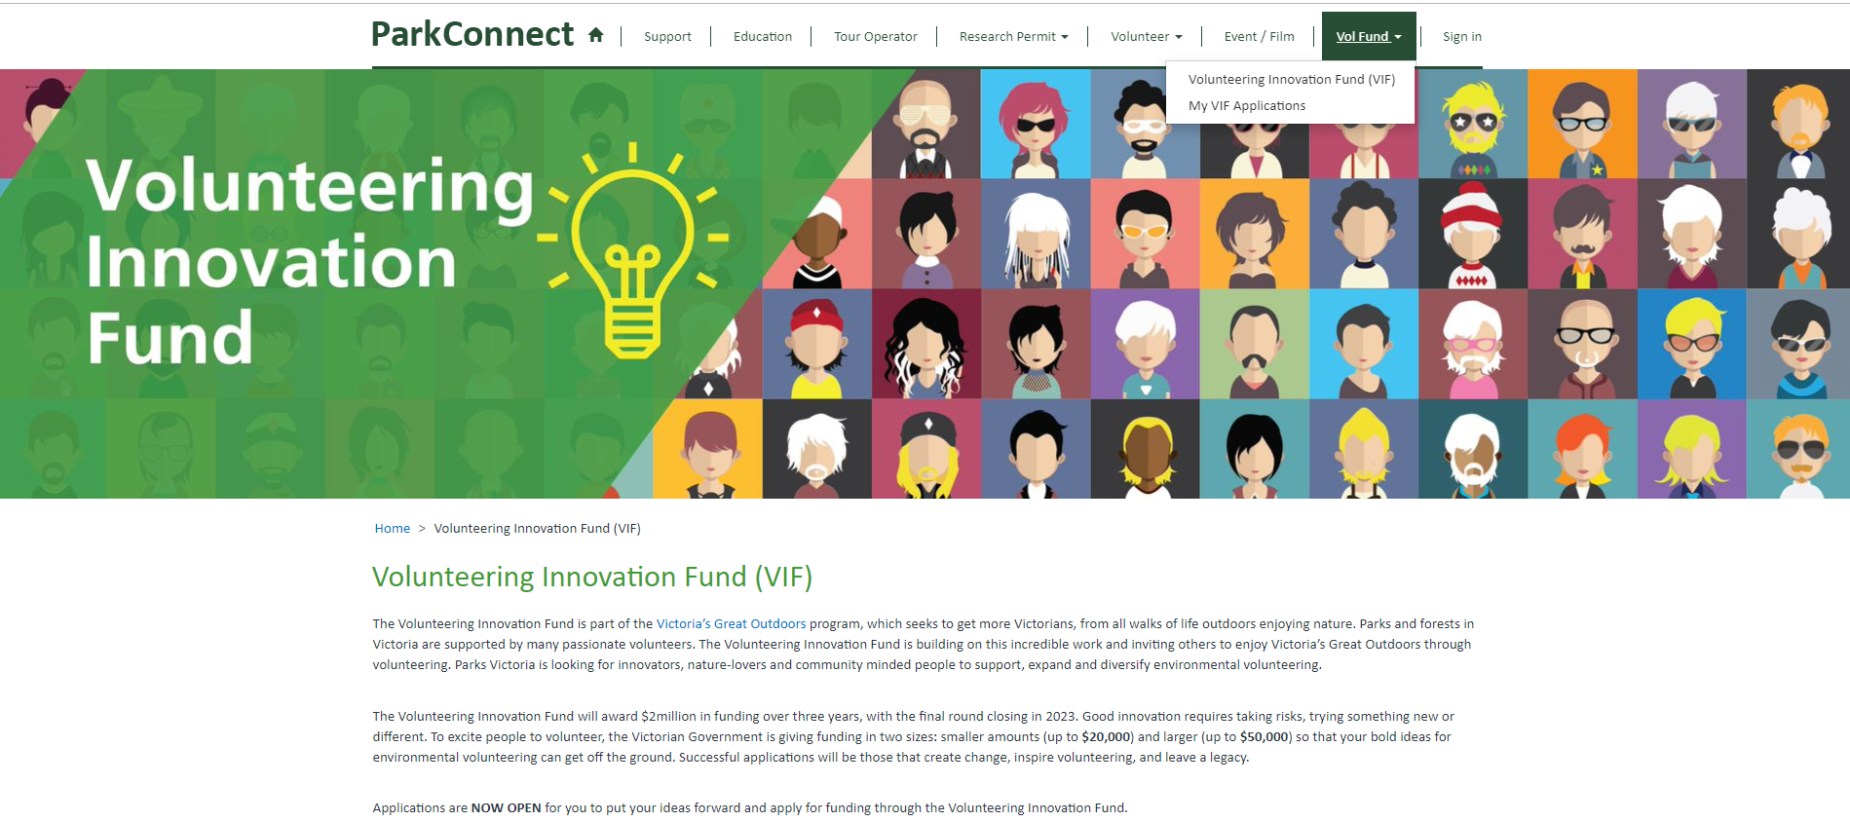

You can access the Funding Guidelines and Fact Sheets on the landing page through the following links. You can also find them on www.parkconnect.vic.gov.au/vif

The VIF dashboard allows you to commence and manage your applications, including project plans, variations and acquittals. You can request a variation by clicking the blue outlined button on the landing page or on your VIF dashboard.

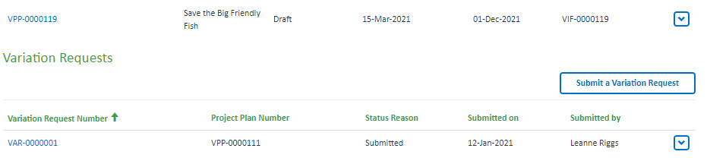

Your draft and submitted project plans will be accessible through your VIF dashboard. If you save a draft project plan, you can access it to review, edit, proof read or submit by clicking on the Application ID or the drop down arrow.
Once you have submitted your project plan you are unable to edit. The project plan will become ‘view only’.

Submit a Variation request
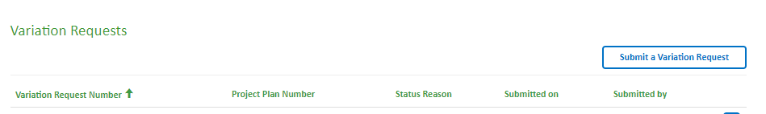
To submit a variation, click on the “Submit a Variation Request” button on your VIF dashboard. This will take you to the first page of the variation.

Select Project Plan
You will need to select the applicable Project Plan you are requesting a variation for. Click on the search icon to bring up your list of project plans.
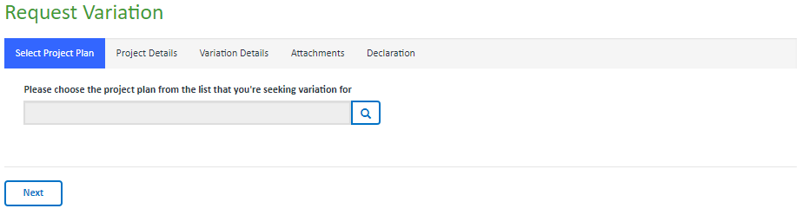
A pop-up box will open. Select the applicable project plan and click “Select”.
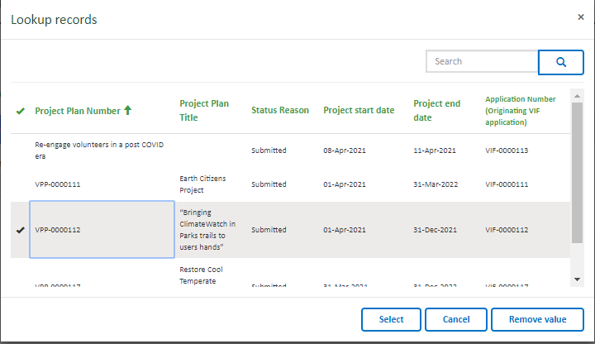

Once selected, you will return to the form. Click “Next”.

Project Details
The information in the Project Details section will be copied across from your application. Please read through to make sure it is the correct application. You will not be able to edit these details.

Click “Next” to go to the next page.
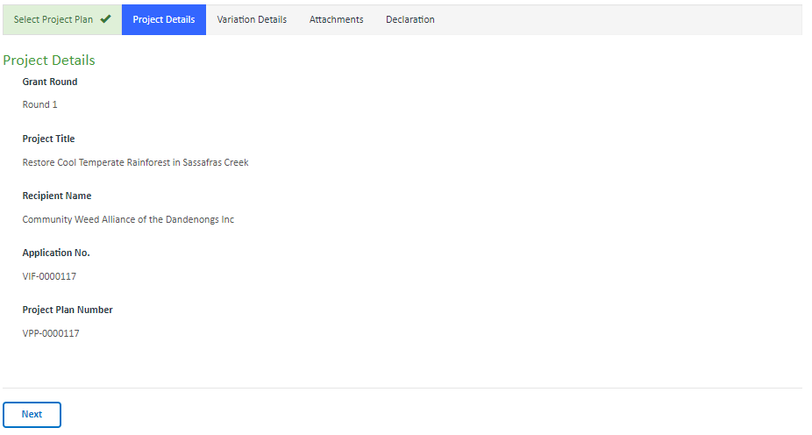

Variation Details
The information in the Variation Details section will capture what you are requesting to vary to your project. Complete the fields that apply to your request. You can request variations to both the date and scope in the same request.

Date
To request a date change, click yes in the ‘Date’ field. The original Due Date will show below for reference. Enter the due date you are requesting. Provide an explanation for the request in the “Why are you seeking a variation?” text box..
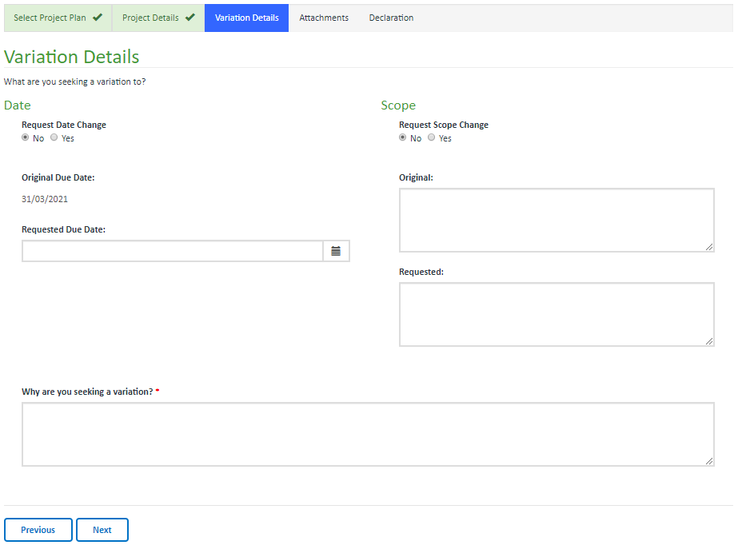
Once you have filled out all required fields, click Next to save your variation.

Next will save the variation and progress to the next page.

Previous will save the variation and go back to the previous page.

The variation will not save until all mandatory fields are completed (and correct). If any of the mandatory fields are not completed correctly, the errors will list at the top of the page in red. You must correct these errors to save, exit to the VIF dashboard or proceed to the next page. Your variation will not save if there are incomplete fields or errors.

Scope
To request a change to the scope of the project (activities, items, events etc), click yes in the ‘Scope’ field. Enter the details of the approved scope in the “original” text box for reference. Enter the scope change you are requesting in the “Requested” text box. Provide an explanation for the request in the “Why are you seeking a variation?” text box.
Once you have filled out all required fields, click Next to save your variation.
Next will save the variation and progress to the next page.
Previous will save the variation and go back to the previous page.

The variation will not save until all mandatory fields are completed (and correct). If any of the mandatory fields are not completed correctly, the errors will list at the top of the page in red. You must correct these errors to save, exit to the VIF dashboard or proceed to the next page. Your variation will not save if there are incomplete fields or errors.

Attachments
The Attachments page provides you the opportunity to further demonstrate your request to vary your project.
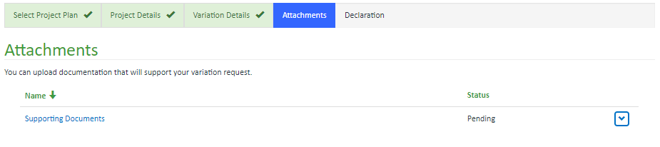

To upload documents, click on the category in blue or the drop down arrow.
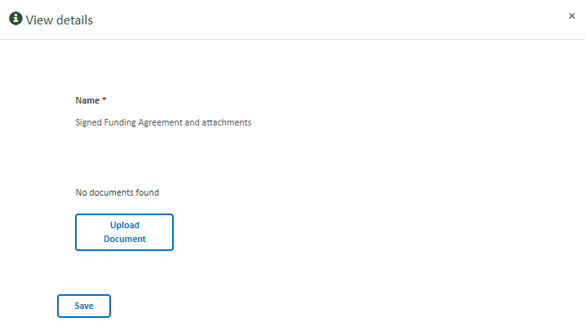

A pop-up-box will open.

Click on the Upload Document button.

A further pop-up box will open.

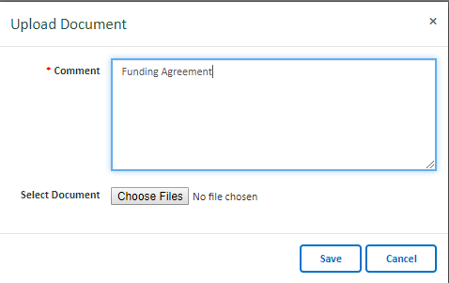

Enter the name of the document. The document will not upload
unless this field is completed. This field will assist with
identification of the document.

Click on the Choose Files button.

A pop-up box will open. Select the document and click open. The document will now show here.

Click on the Save button.
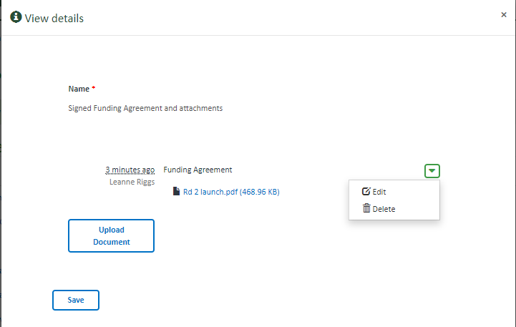

You will return to the View Details pop-up box.

The uploaded document should now show. You can edit or delete
the document by clicking on the drop down arrow.

You can upload more documents by clicking on the
Upload Document button and repeating the above instructions.

Once all documents are uploaded, click on the Save button.

Upon clicking Save you will return to the project plan. The Status in the table will now show as submitted. You can edit the uploaded documents by clicking on the drop down arrow.

Upload more documents by repeating the above instructions.

Once you have filled out all required fields, click Next to save your variation.

Next will save the variation and progress to the next page.

Previous will save the variation and go back to the previous page.

The variation will not save until all mandatory fields are completed (and correct). If any of the mandatory fields are not completed correctly, the errors will list at the top of the page in red. You must correct these errors to save, exit to the VIF dashboard or proceed to the next page. Your variation will not save if there are incomplete fields or errors.

Declaration
The Declaration page confirms your responsibilities when submitting the variation. You must agree to the declarations to submit the variation.

If you agree with the declarations, select yes.

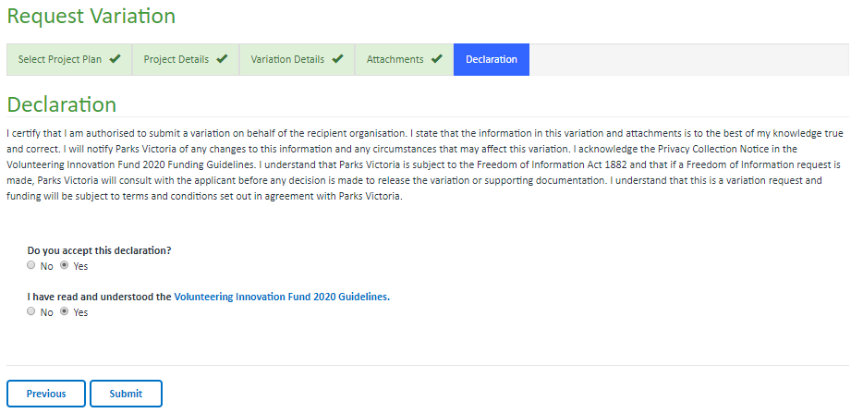

Once you have reviewed the declaration, you can click Previous or Submit.

Previous will save the variation and return to the previous page.

Submit will save the variation and Submit to us for review. Once submitted you will no longer be able to edit your variation. Once submitted, the nominated Contact person will receive an email confirming the variation has been submitted. You can return to the Dashboard to view the variation at any stage.

